Antonio Charles Woodard
November 27, 1990 – April 26, 2021
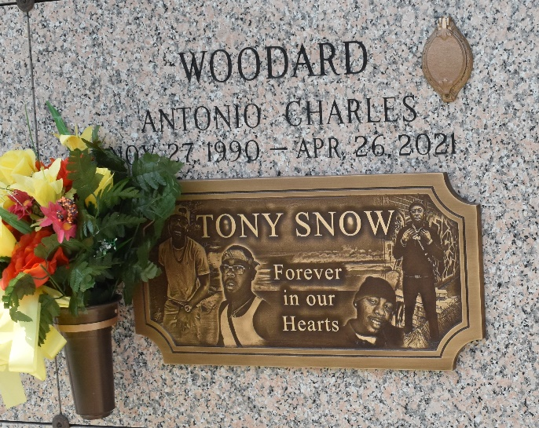
Antonio Charles Woodard was born on November 27, 1990 to Patricia and Willie James. He attended school in LaPlace, LA and was a 2010 graduate of East St. John High School. He later attended Delgado Community College where he graduated with an associate degree in Business Management. Antonio and his brother, Joshua became franchise owners of Jani King Janitorial service. After a couple of years of janitorial work, he went back to his first love, MUSIC. He started his own music production company called Son of the Sand LLC. He also obtained his CDL license and was a beloved school bus driver until his departure.
Antonio had a love for family and fashion. He was the true definition of a "Momma's Boy". Antonio was well loved by everyone he encountered. He was affectionately known by many nicknames such as "Tony, Tonio, Snow, Gucci and his childhood nicknames Sparky, Small Change, Tank Tank, and Yo-Yo". He would light up a room with his presence Antonio was always cracking jokes, being playful and sarcastic. He was very outspoken, but as soon as you saw his smile, you knew it was all love. He loved traveling and visited many places. In his spare time, he liked to relax and watch movies. Antonio believed in Jesus and accepted him as his Lord and Savior.
Antonio entered into Eternal life on Monday, April 26, 2021. His passing has brought sadness to the hearts of all those who loved him. He is survived by his loving parents, Patricia and Willie James Sr.; brothers, Joshua (Angel) Woodard Sr., Ashton Rodney, Willie James Jr., and William (Chelsea) James; sisters, Latricia Sias, JaKeithia Ivey, Kiristen Byrd, Shawnell (Chris) Thiel and Breion James; grandparents, Leonard Woodard Jr., and Willie Earl and Rose James; aunts, Sharon Kimble, Betty Turner, and Renee (Alton) Butler; uncles, Paul Butler and Terry James Sr.; Godchildren, Shaniyah, Jaleyah, Michael, Joshua Jr., JaKai, Javen, Tiger and JaZiyah, and a host of other nieces, nephews, cousins and friends.
He was preceded in death by his grandmothers Dorothy Woodard and Sadie Mae Robinson; aunts, Carol James and Jessica Woodard, and brother; Justus Davis.
A celebration of the life of Antonio Woodard will be held on Saturday, May 1, 2021 at First Assembly of God Church, 3001 US-52, LaPlace, LA 70068. Visitation period will be held from 10am-11am. Service will begin at 11am. Minister Wilfred Wright officiating. Entombment to follow at St. John Memorial Gardens in LaPlace, LA.

Treasures of Life Center for Funerals, Gramercy, Louisiana

