Jimmie Woods
December 28, 1928 – January 10, 2019
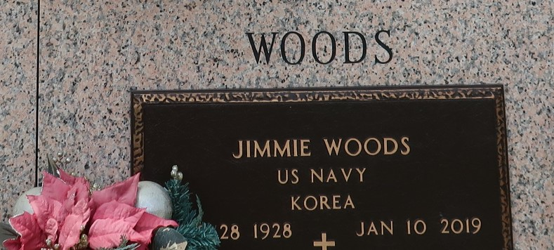

Jimmie Woods went to be with the Lord on Thursday, January 10, 2019. He was 90, a native of Pioneer, LA and a resident of LaPlace, LA. Beloved husband of the late Clauzelle Bryan Woods. Father of Patricia Cortez (Edward), Phillip Woods (Gina), Susan Kozan (Donald) and James Woods (Rebecca). Son of the late Jessie Woods and James Woods. Brother of the late Jackie Beaver, Joe Woods and Barbara Green. Also survived by 12 grandchildren, 13 great-grandchildren and many nieces and nephews.
He was an active member of First Baptist Church of LaPlace where he served as a deacon. He retired from Entergy after 30 years of service. He proudly served our country in the US Navy on the USS Richard B. Anderson during the Korean War.
Relatives and friends are invited to attend the Funeral Service at First Baptist Church of LaPlace, 120 Ormond Blvd., LaPlace on Saturday, January 12, 2019 at 2:00 p.m. Visitation from 12:00 p.m. until 2:00 p.m. Interment in St. John Memorial Gardens Cemetery. In lieu of flowers, please consider a donation in his memory to First Baptist Church of LaPlace Building Fund, 120 Ormond Blvd., LaPlace, LA 70068. To view or sign the online guest book, please visit www.milletguidry.com.

The New Orleans Advocate, Louisiana
Jan. 10 to Jan. 12, 2019

