Margie Young
1931 – March 13, 2017
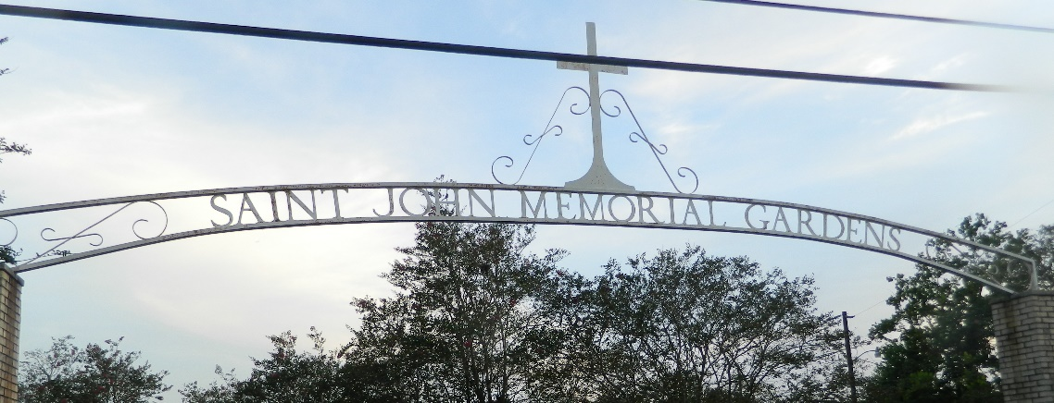

Margie Young "Chinoon" on Monday, March 13, 2017, at her home in Reserve, LA. Daughter of the late Agnes Jones and Noah Young. Mother of Donna Young, Jessie Veal and Joyce Young. Sister of Freddie Young, Theresa Young, Lois Bright, the late Pensacola Young and Hilda Keller. Also survived by 4 grandchildren, 3 great grandchildren and a host of nieces, nephews, cousins, other relatives and friends. Age 85 years. A native and resident of Reserve, LA.
Relatives and friends of the family, also priest and parishioners of Our Lady of Grace Catholic Church, Beech Grove Baptist Church, Tchoupitoulas Chapel, Foundation of Faith of Gonzales, LA and all neighboring churches and employees of Performance Construction and Twisted Burgers are invited to attend the Funeral Mass at Our Lady of Grace Catholic Church, 772 Hwy 44, Reserve, LA on Saturday, March 25, 2017, at 10:00 AM. Father Christopher Amadi, SSJ, Celebrant. Interment St John Memorial Gardens Cemetery, LaPlace, LA. Visitation at the above-named church from 8:15 AM until Mass time. Rosary at 9:15.
The Times-Picayune, New Orleans, Louisiana
Mar. 20 to Mar. 24, 2017

