Maisie (Keating) Abadie
December 20, 1933 - June 2, 2024

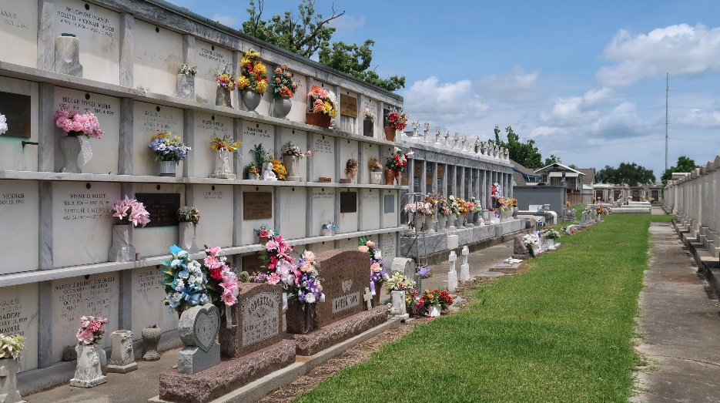

Maisie Keating Abadie passed away peacefully at the age of 90 on June 2, 2024 at her home surrounded by her husband and family. She was a loving wife, mother, sister, grandmother, and great-grandmother. She dedicated her life to caring for her family. She was often found in the kitchen cooking and baking delicious meals – especially every Sunday when she prepared dinner for the family who gathered in her home. Her sewing skills were unmatched. She lovingly tailored much of the clothing for her six children and enjoyed spending time in her sewing room teaching her daughters and grand-daughters how to sew. Her gardens brought her great joy. She loved tending to the bright flowers that adorned her yard and was always ready to put together a bouquet for her neighbors, her friends, and for her children and grandchildren every May for the Crowning of Mary.
Devoted wife of 68 years to Amedee Abadie. Nurturing mother of Sharon Abadie, Gail Surla (Dio), Lisa Triche (Randy), Allison Duhe (Dennis), Amy Whitehead (Jerry), and the late Mark Abadie. Caring grandmother of Nicole Strauss, Erin Autin (Ben), Sarah Triche, Brandon Duhe, and Zachary Surla. Proud great-grandmother of Henry Autin. Daughter of the late Viola Alexander and Eddie Keating. Sister of Terry Keating (Brenda), the late Larry Keating, the late Malcolm Keating (Gloria), and the late Donald Keating (Reiko). The family would like to express their heartfelt appreciation to Ashley, Kristie, and Shyla of St. Catherine’s Hospice and to Dr. Colin Bailey for their loving and compassionate care.
Relatives and friends are invited to attend the funeral services on Friday, June 7, 2024 at St. Joan of Arc Church, 529 W. 5th Street, LaPlace. Visitation will be at the Church from 10:00am-11:00am with the Funeral Mass to follow at 11:00am. Interment will be in St. Peter Cemetery. In lieu of flowers, the family requests that donations be made for Masses to be celebrated in her memory.

Millet-Guidry Funeral Home, LaPlace, Louisiana
June 5, 2024

