Robin Lynn Alexander
October 13, 1972 – January 1, 2007

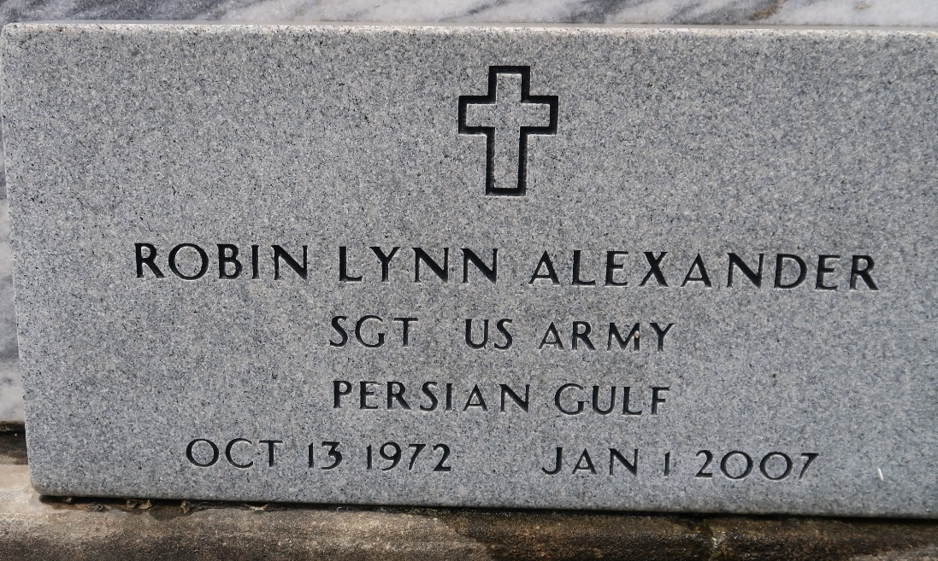
Photo by Team T-Lo

Robin Lynn Alexander, on Monday, January 1, 2007 at 6:38 pm. Beloved daughter of Robert and Janet V. Alexander. Sister of Melissa A. Roussel and Jennie Alexander. Sister-in-law of Terry Roussel . Aunt of Madisen and Evan Roussel. Niece of Penny and Mike Dufrene, Mary and Gene Powell and Todd and Lisa Vicknair. Granddaughter of Marie Morgan and the late Francis Vicknair. Godchild of Anthony Ringo. She was a Staff Sergeant in The United States Army. Age 34. A native and resident of Laplace.

Relatives and friends of the family, also employees of Exxon Mobil are invited to attend services. Visitation at Millet-Guidry Funeral Home, 2806 W. Airline Hwy, Laplace on Wednesday, January 3, 2007 from 5 pm to 9 pm and on Thursday from 8 am to 10 am. Followed by Religious Services at the funeral home chapel at 10 am. Burial in St. Peter Cemetery, Reserve
Times Picayune, New Orleans, Louisiana
January 3, 2007

