Roy Amedee Sr.
August 25, 1943 – September 21, 2021

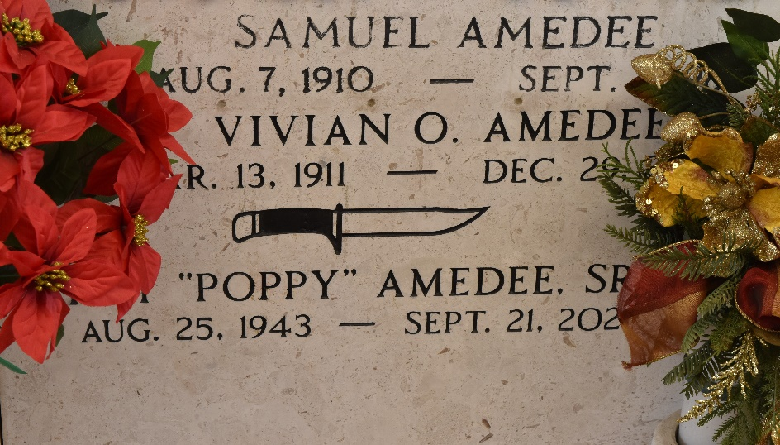

Roy "Poppy" Amedee Sr. was born on August 25, 1943 in New Orleans, LA and was a lifelong resident of Garyville, LA. He passed away on September 21, 2021 at the age of 78. He was a loving husband, father, and grandfather. Poppy was a talented artist and craftsman. If he wasn't spending time with family and friends, he could be found in his shed working on his newest creation. He also enjoyed hunting, fishing, and LSU football.
Poppy is survived by his wife, Laura Vicknair Amedee; son, Roy Amedee Jr. (Sheryl); granddaughter, Jammi Amedee (Ashleigh); and Gary Cashio (Marsha), Joanna LeBlanc, and Becky Hoffman (Wayne).
Sadly, his daughter, Cherie Holden, passed away shortly after on the same day. He is preceded in death by his parents, Samuel and Vivian Amedee.
A visitation will be held at St. Hubert's Catholic Church in Garyville, LA on Tuesday, September 28, 2021 from 9:00 AM to 11:00 AM followed by a Mass of Christian Burial. Interment will be in the St. Peter's Catholic Church Cemetery.
Rose Lynn Funeral Home, Lutcher, Louisiana

