Vivian (Oubre) Amedee
March 13, 1911 – December 29, 2001

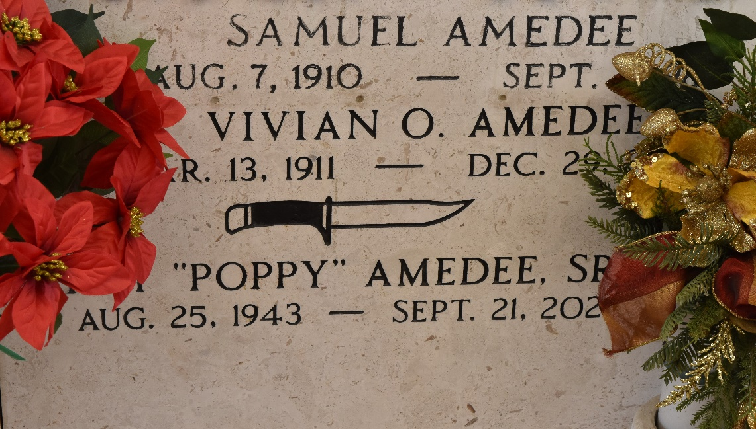

GARYVILLE - Vivian Oubre Amedee, 89, a native and resident of Garyville, died Dec. 29. She was the wife of the late Samuel Amedee and mother of Roy Amedee Sr. She was also the daughter of the late Theophile and Lena Lorio Oubre and sister of Anna Mae Cashio and the late Leroy Oubre. She is also survived by two grandchildren and one great-grandchild.
Services were Dec. 30 at St. Hubert Catholic Church, Garyville, with interment at St. Peter Cemetery, Reserve.
L'Observateur, LaPlace, Louisiana
January 2, 2001

