Danny Anderson
August 27, 1955 – September 26, 2009

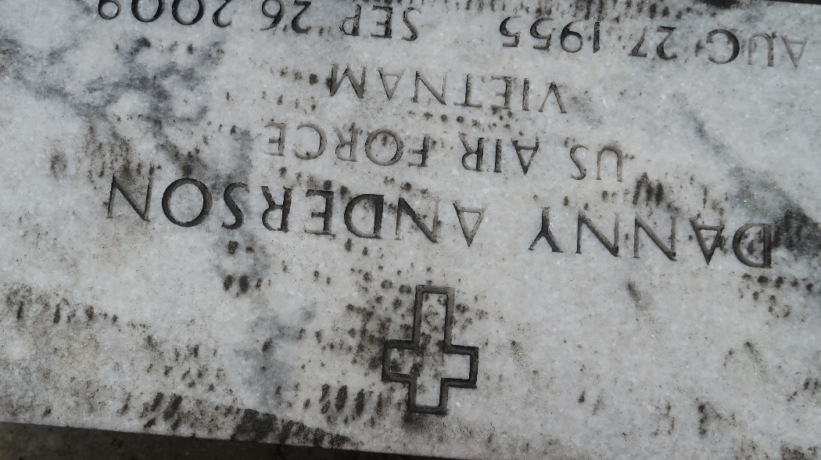

Danny Anderson on Saturday, September 26, 2009 at Tulane Hospital, New Orleans, LA. Age 54 years. A native and resident of LaPlace, LA.
Son of Felice Anderson Brown and the late Freddie Anderson.
Brother of Mary Ann Parquet, Octarve Anderson, Freddie Lee Brown, Randolph Anderson, Anita Clement, Clayton Anderson, Elise Perrilloux, Joey Anderson, Brenda Exxum, the late Audrey Wilson, Silvia and Larry Anderson.
Times-Picayune, New Orleans, Louisiana
October 1, 2009

