Jesse Rita (Booker) Arceneaux

January 26, 1920 – June 16, 2004

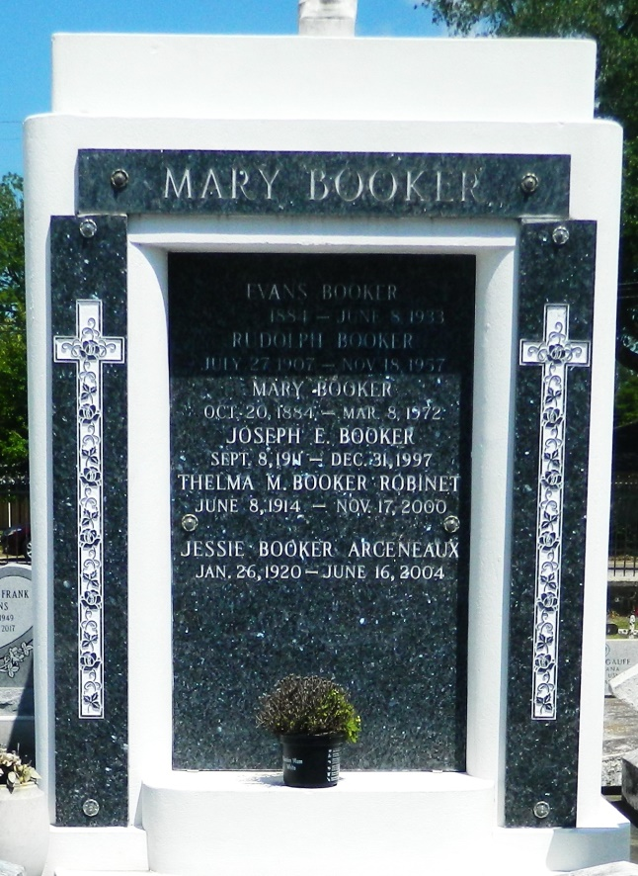 

Jessie Rita Booker Arceneaux, on Wednesday, June 16, 2004 at her residence, Reserve, LA. Daughter of the late Mary Brown and Evans Booker. Wife of the late Ernest Arceneaux. Mother of Ernest Arceneaux of Atlanta, GA, Michael and Patrick Arceneaux both of Reserve, LA, Janice Arceneaux of Atlanta, GA and Judith Arceneaux of Houston, Texas. Mother-in-law of Mary Ann Laureen Arceneaux. Sister of Isabella Keller of Reserve, LA, Royal Booker of Richmond, VA, the late Rudolph Booker, Thelma Robinet and Joseph Booker. Also survived by 4 grandchildren, 6 great-grandchildren, a host of nieces, nephews, other relatives and friends. Age 84 years. A native and resident of Reserve, LA.  
 Relatives and friends of the family, also priest and parishioners of Our Lady of Grace Catholic Church and all neighboring churches are invited to attend the Mass of Christian Burial at Our Lady of Grace Catholic Church, 772 Highway 44, Reserve, LA on Saturday, June 19, 2004 at 11:00 a.m. Father of Joseph Rodney - celebrant. Interment St. Peter Cemetery, Reserve, LA. Visitation at the above named Church from 9:00 a.m. until Mass time. Recitation of the Rosary at 10:15 a.m.  
 In lieu of flowers, donations to Our Lady of Grace Catholic Church.  
 SERVICED BY ROBOTTOM

Times-Picayune, The (New Orleans, LA) - Friday, June 18, 2004

Contributed by Jane Edson