Patricia (Duhe) Arceneaux
September 11, 1925 – May 25, 2011

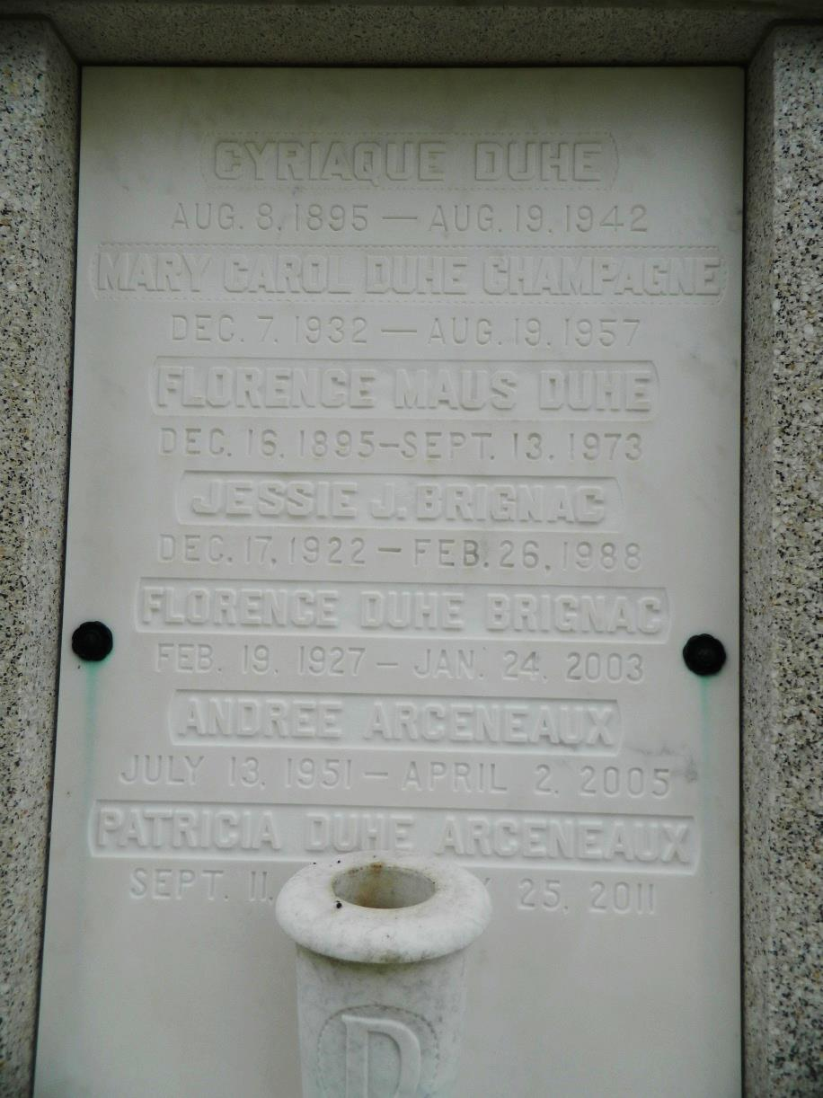

Patricia Duhé Arceneaux passed away on Wednesday, May 25, 2011. Beloved wife of Arthur J. Arceneaux, Jr., for 65 years. Mother of Annette Zimmer (Max), Rosalie Blanke (Kenny), Arthur J. Arceneaux, III (Debbie) and the late Andrée Arceneaux. Also survived by four grandchildren (Erica, Kenny, Max, and Timmy), four great-grandchildren (Mackenzie, Kenny, Christian, and Alex), four step-grandchildren (Michael, Melissa, Kendal, and Lauren), and one step-great-grandchild (Geno). Daughter of the late Cyriaque and Florence Duhé. Sister of the late John Richard Duhé, Florence Brignac, and Mary Carol Champagne. Patricia was 86 years old, a native of Reserve, LA, resident of Harahan, LA, and member of St. Rita of Cascia Catholic Church.
Relatives and friends are invited to attend services. Visitation at Millet-Guidry Funeral Home, 2806 W. Airline Hwy., LaPlace, LA, on Wednesday, June1, 2011 from 9:00 am to 10:00 am, followed by memorial services in the Funeral Home Chapel at 10:00 am. Burial in St. Peter's Cemetery, Reserve, LA.

Times-Picayune, The (New Orleans, LA) - Sunday, May 29, 2011
Contributed by Jane Edson

