Rachel (Sanson) Armour
August 4, 1969 – October 17, 2022

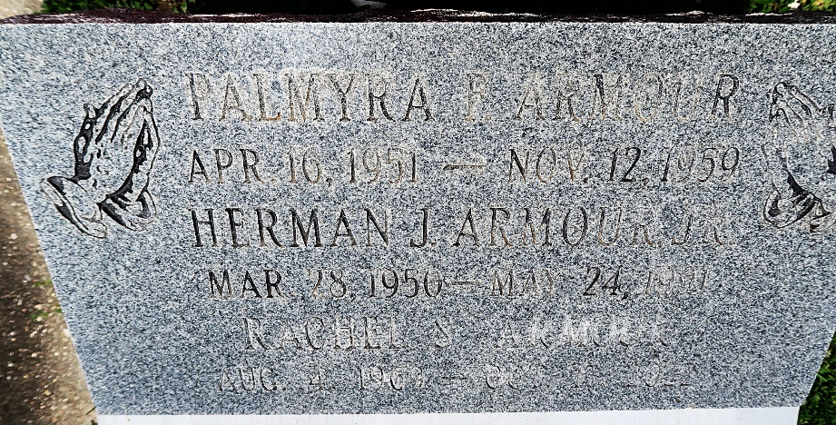

Rachel Sanson Armour transitioned from her earthly life on Monday, October 17, 2022 in Natchitoches, LA at the tender age of 53. Born on August 4, 1969 to the union of the late Tommy Etta and Riley Sanson, Sr. She was the loving wife of Stephen Armour, Sr. Sister of Raphael Sanson of Jacksonville, FL. Doting Stepmother of Nakesha (Tyrone) Buckley, Nadiah Armour and Stephen (Tereza) Armour, Jr. Step-Grandmother of Tyneah and Natyah Buckley, Jayven Jones, Xavier and Sean Armour. Daughter-in-law of Wilhelmina and Herman Armour, Sr. Sister-in-law of Mark (Maxine) Armour, Jason (Kim) Armour, and late Herman Armour, Jr. and Michael Armour, Sr. She was the dear friend of Marsha MCculler and Melanie Girod, also the special friend of Penny Brown Reynolds and nephew Michael Armour, Jr. Also survived by a host of friends and family.
She was a graduate of East St. John High School Class of 1987. She received a bachelor's degree from Louisiana College, Alexandria, LA, also a graduate of McModal Medical Transcription, CAREER STEP for Billing and Coding.
Relatives and friends of the family are invited to attend a Celebration of Life on Saturday, October 22, 2022 at 11:00am at the Patrick H. Sanders Funeral Home, 605 Main Street, Laplace, LA 70068. Rev. Neil Bernard, Officiating. Visitation 10:00am until time of service. Interment at St. Peter Catholic Cemetery, Reserve, LA 70084.

Patrick H. Sanders Funeral Home, LaPlace, Louisiana
October 27, 2022

