Amanda Marie (Hotard) Audiffred

October 8, 1915 – October 31, 1966

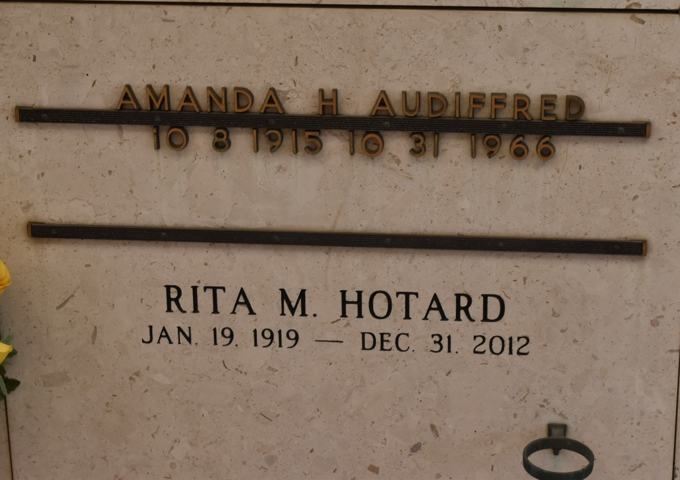

At Baton Rouge General Hospital on Monday, October, 31, 1966 at 8 o'clock p.m. AMANDA HOTARD AUDIFFRED, mother of Mrs. Earl Perque and Mrs. Joseph Remondet of Reserve, LA, and Dianne Audiffred of New Orleans, LA, daughter of Mrs. E. X. Hotard and the late E. X. Hotard, sister of Henry, Albert, Etienne L., and Sidney Hotard of Reserve, LA, Mrs. C. F. Williamson and Mrs. Edward Sutton Jr. of Reserve, LA, and Miss Rita Hotard of New Orleans, LA, also survived by 7 grandchildren, age 51, a native of Luling, LA, and resident of Baton Rouge, LA for the past 5 years.
Times-Picayune, New Orleans, Louisiana
November 2, 1966

