Bruce M. Audiffred

September 6, 1940 - January 22, 2024

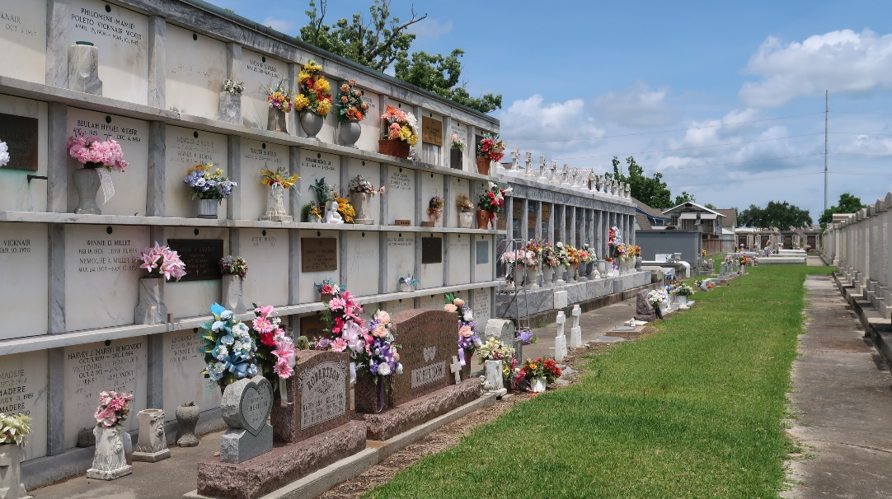

Bruce M. Audiffred passed away on Monday, January 22, 2024. He was born September 6, 1940 to the late Ellis and Camelia Audiffred. Born in New Orleans, LA and a lifelong resident of Reserve, LA.
Beloved husband of Mary Michel Audiffred for 63 years. Loving father of Deric Audiffred (Rhonda), Glenn Audiffred (Tracy), and Jody Audiffred (Dorri). Grandfather of Justin (Alice), Chelsie, Mary Katherine, Sarah, Devin (Goldie), Dylan, Drake, and Laken Audiffred. Great Grandfather of Olivia and Madelynn Audiffred. Brother of Karen Laurent (Merlyn). Also survived by many nieces and nephews.
A Graveside Service was held at St. Peter’s Cemetery in Reserve, LA on January 26, 2024.

Millet-Guidry Funeral Home, LaPlace, Louisiana
January 27, 2024

