Fernand Joseph Aycock, Sr.

1886 – October 21, 1964

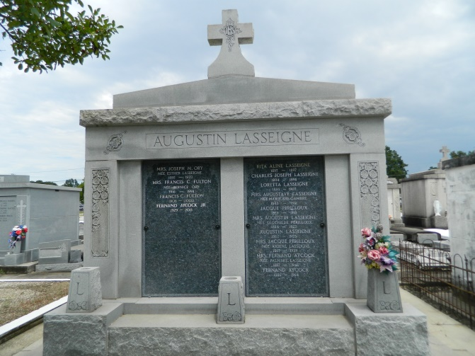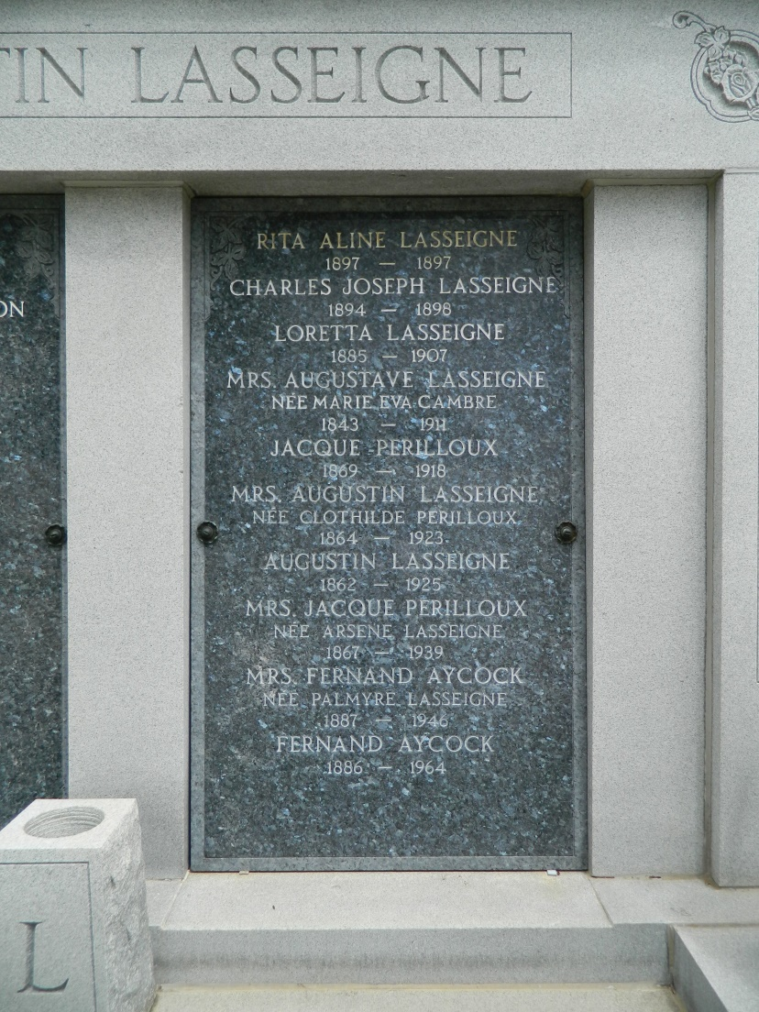

Age 76 years, a resident of Laplace, Louisiana. Husband of the late Palmyre Lasseigne and father of Mother Damien Aycock, O.S.U. of New Orleans, Mother Joan Marie Aycock, O.S.U. of Dallas, Texas, Mrs Teresa Madere and F J Aycock Jr both of Laplace. He was the brother of Mrs. Corinne Kaufman of Cottenport, Louisiana, Dr. J B Aycock of Lafayette, Louisiana, and Dr. Garland Aycock of Franklin, Louisiana. Services were Friday, 23 Oct 1964, at St Joan of Arc Church, Laplace, with interment in St Peter Cemetery, Reserve, Louisiana.

**The Times-Picayune 23 Oct 1964**

**Contributed by Dwayne Montz**