Harold X. Ayme
August 28, 1946 – May 22, 2014

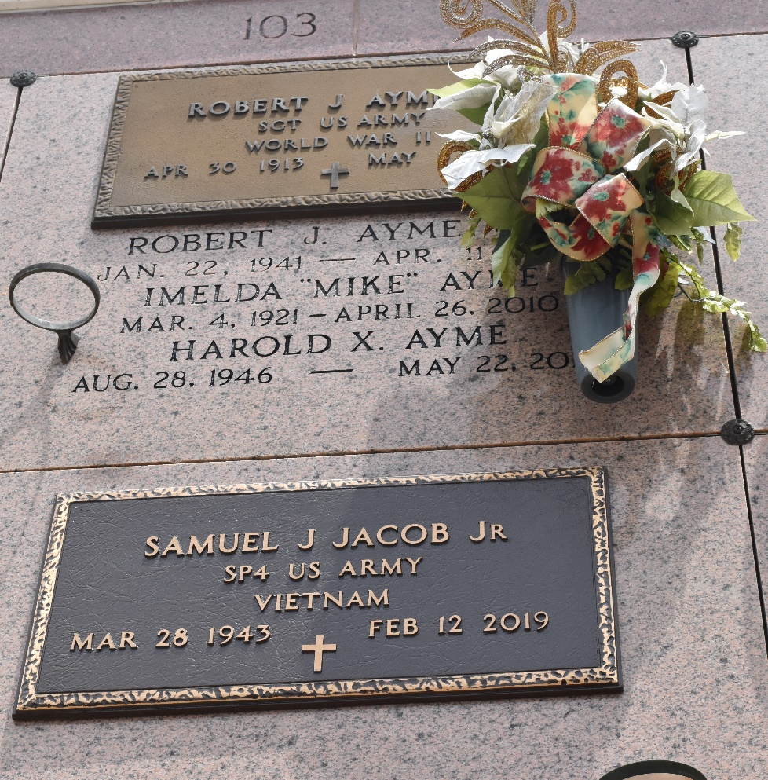

Harold X. Ayme passed away on May 22, 2014 at the age of 67 after a long and valiant battle with MS. A native of LaPlace, LA, he was a member of the prestigious Army Field Band during the Vietnam War. He went on to play clarinet with the San Diego Symphony and the Baton Rouge Opera Orchestra. He also played a funky sax with "The Sabers", later known as "The Bits and Pieces", a well-known band in the River Parishes. In recent years, he lived in Ohio to be close to his children.
He is survived by his daughter and son, Ashley and Matthew Ayme, of Columbus, Ohio. He is also survived by his sister, Kathy Delia, and brother, George Ayme. He is the son of the late Robert Ayme, Sr. and Imelda "Mike" Ayme. He was preceded in death by brothers, Bobby and Larry Ayme.
Visitation for family and friends will be at Millet Guidry Funeral Home located at 2806 W. Airline Highway, LaPlace, LA on Tuesday, May 27, 2014 from 8-10 a.m. followed by mass and then interment at St. Peter's Cemetery in Reserve, LA. In lieu of flowers, the family requests that donations be made to the VA Fisher House in St. Louis, MO
www.fisherhouseinstl.org/Contribute/Make-Donation.aspx

The Times-Picayune, New Orleans, Louisiana
May 23 to May 25, 2014

