Ethel (Landry) Badeaux
July 18, 1921 – March 25, 2006

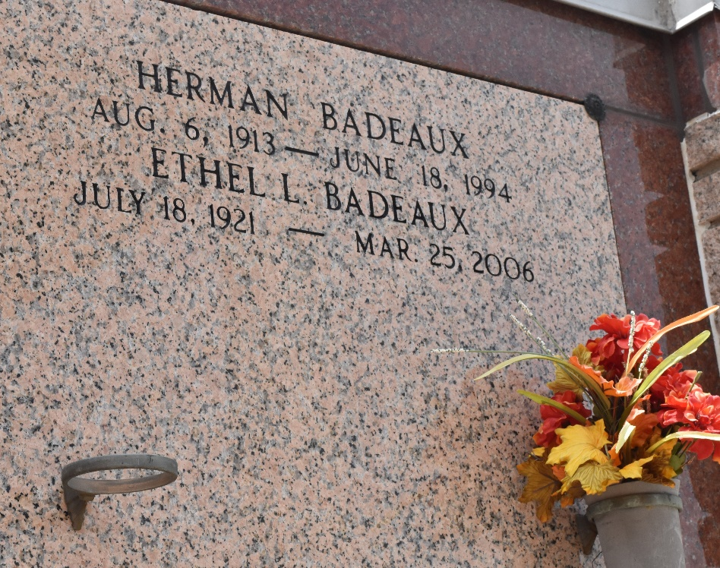

Ethel Landry Badeaux on Saturday, March 25, 2006 at 1:00 a.m.

Beloved wife of the late Herman Badeaux. Mother of Bruce Badeaux, Evelyn Schwab and Jean Simon. Daughter of the late John Sr. and Antoinette Landry. Sister of John Jr., Garland and Audrey Landry and the late Rudolph and A.J. Landry, Helen Ory and Clara Melancon. Also survived by 5 grandchildren and 10 great-grandchildren.

Age 84. A native of Convent and a resident of Garyville for the past 40 years.
Times Picayune, New Orleans, Louisiana
April 1, 2006

