Timothy Paul Badeaux

December 3, 1963 – December 23, 2006

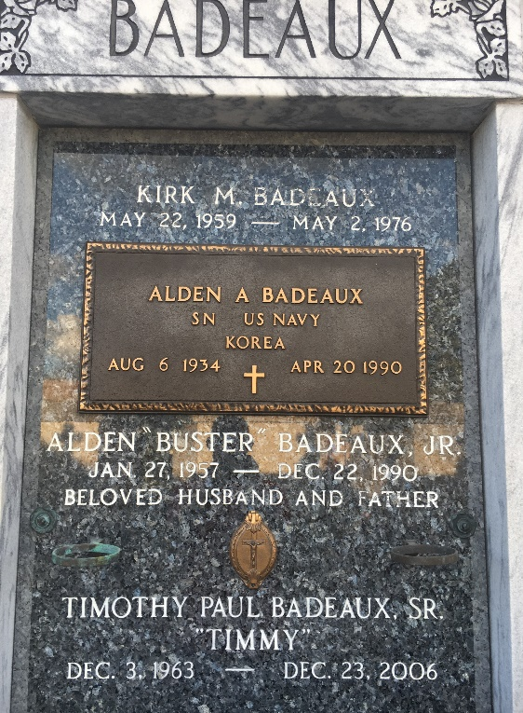

Photo by Team T-Lo

Timothy P. Badeaux, Sr. on Saturday, December 23, 2006 at 9 am. Beloved husband of Helen Badeaux. Father of Timothy P. Badeaux, Jr. and Macy Marie Badeaux. Son of Janice Amedee LeBouef and the late Alden Badeaux. Brother and brother-in-law of Troy and Michelle Badeaux, Cindy and Michael Champagne, Lindy and Lionel LeBouef and the late Alden (Buster) Badeaux, Jr. and Kirk Badeaux. Age 43. A native and resident of Garyville.

Relatives and friends of the family, also employees of Shell Chemical and Motiva are invited to attend services. Visitation at Millet-Guidry Funeral Home, 2806 W. Airline Hwy, Laplace on Thursday, December 28, from 5 pm to 10 pm and on Friday from 8 am to 9:30 am. Followed by religious services at St. Peter Catholic Church, Reserve at 10 am. Burial in St. Peter Cemetery, Reserve.

Times Picayune, New Orleans, Louisiana

December 28, 2006