Roy M. Bakewell, Jr.
April 7, 1951 - May 9, 2024

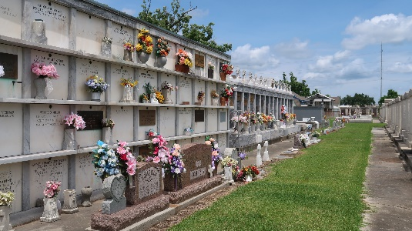

Roy M. Bakewell, Jr. passed away peacefully at his home on Thursday, May 9, 2024 at the age of 73. Roy was born in New Orleans, LA, and was a resident of LaPlace, LA.
Beloved husband of Catherine Millet Bakewell. Son of the late Margaret Aycock Bakewell and Roy M. Bakewell, Sr. Brother of Letty McDaniel, Margaret B. Keogh (Dennis), and Michael D. Bakewell (Martha). Brother-in-law of Richard and Suzanne Klibert, Danny and Henrietta Millet, Gus Lehmann and the late Rachel Lehmann, and Marcelle and E.J. Bailey. Uncle of Kristen McDaniel and Judeson McDaniel, Carrie Lynn Daigle and Dustin P. Bakewell, Melinda Bakewell and Connie Sycheck, Rickey Klibert, Christine Creppel, Bryan Klibert, Leslie Faucheux, Jay Bailey, Natalie Dewey, Gustave Lehmann, Shaun Lehmann, Kelly Klibert, Daniel Millet, Adam Millet and Peter Millet. Roy is also survived by the spouses of his beloved nieces and nephews, their children, and many dear friends.
Roy graduated from Holy Cross High School in New Orleans, LA, with the class of 1969. He attended USL in Lafayette where he was a member of Lambda Chi Fraternity and in 1974 graduated with a Bachelor’s degree in Liberal Arts. Roy worked in the oilfield industry for over 35 years from which he retired in 2016. His hobbies were enjoying time with family and friends, especially over a good bottle of wine, great food, and bodacious music. In the younger years, Roy was a creative artist and enjoyed playing golf and tennis, as well as riding dirt bikes and basically creating the fun. He was always up for an adventure or trip and cherished making memories with his family and friends. Roy, who always kept everyone on their toes with his clever wit and quick comebacks, was a generous giver of his time and treasure, a gracious host, and the best pseudo-weatherman to his family. He will be greatly missed by his entire family.
Catherine would like to thank his team of hospice caregivers from Notre Dame Hospice and especially his personal caregivers, Sue Taylor and Fran Nicaud.
Relatives and friends are invited to attend the Funeral. A Funeral Mass will be celebrated at St. Peter Catholic Church, 1550 Hwy 44, Reserve on Friday, May 17, 2024 at 11:00 a.m. Visitation at the church from 9:00 a.m. to 11:00 a.m. Interment in St. Peter Cemetery, Reserve, LA. In lieu of flowers, contributions to St. Joan of Arc School in Roy’s name would be greatly appreciated.

Rose Lynn Funeral Home, Lutcher, Louisiana
May 14, 2024

