Marielee (Labiche) Bass
March 2, 1919 – September 3, 2007

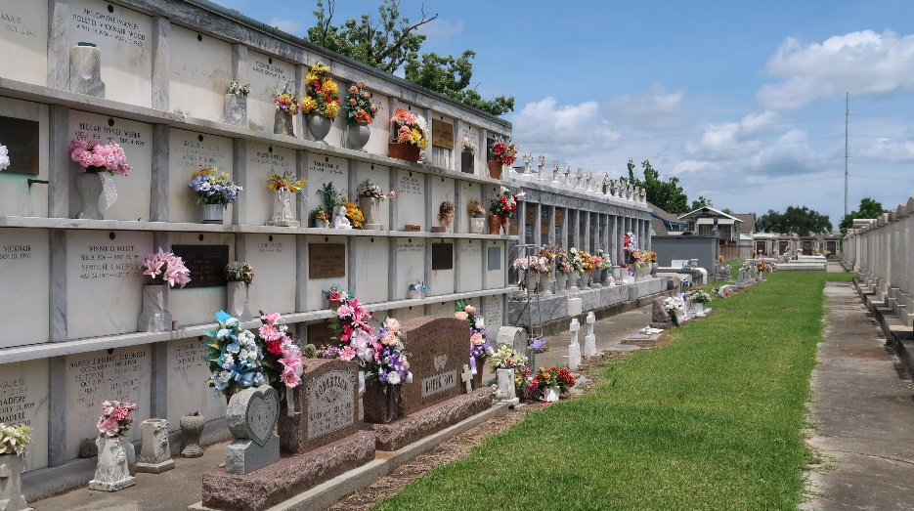

Marielee Labiche Bass died Monday, Sept. 3, 2007. She was born on March 2, 1919, in Louisiana to Ann Bernadette "Annette" Ory and Alfred Louis Labiche.
She was a longtime resident of New Orleans, temporarily residing in Baton Rouge since Hurricane Katrina. She was the widow of Robert Brucks Bass, originally of Chicago and New York City. Marielee served as a first lieutenant in the U.S. Army Nurses Corps in World War II and was attached to the LSU unit, 64th General Hospital, in North Africa and Italy for the duration of the war. She was a graduate of Hotel Dieu School of Nursing, New Orleans. Marielee's career as a nurse included public health, psychiatric, cardiac and industrial nursing positions, retiring from Procter & Gamble/Folger's, New Orleans when she was 70. She was a member and past president of the Industrial Nurses Association, and a member of the Daughters of the Confederacy, Raphael Semmes Chapter.
Marielee is survived by her three children, Charlotte A. Bass and husband Edward J. Lilly, Robert B. Bass Jr. and wife Sally Hodge, and Michelle M. Bass and husband Brian M. Bruce; two grandchildren; and her sister, Joycelyn Schowalter, of Baton Rouge. She was predeceased by her sisters, Genevieve Clarke, who was of Long Island, N.Y., and Yvonne Maurin, who was of LaPlace; and a brother, Merle Labiche, who was of Beaumont, Texas. In lieu of flowers, donations should be directed to Animal Rescue New Orleans, http://www. animalrescueneworleans.org, in her memory. A funeral Mass will be held at noon on Saturday, Sept. 8, with visitation from 9 a.m., at Schoen Funeral Home, 3827 Canal St., New Orleans. Burial will follow at St. Peter's Catholic Church, River Road, Reserve.
The Advocate, Baton Rouge, Louisiana
September 7, 2007

