Lotte Emma (Baumann) Battard

About 1927 – January 4, 2023

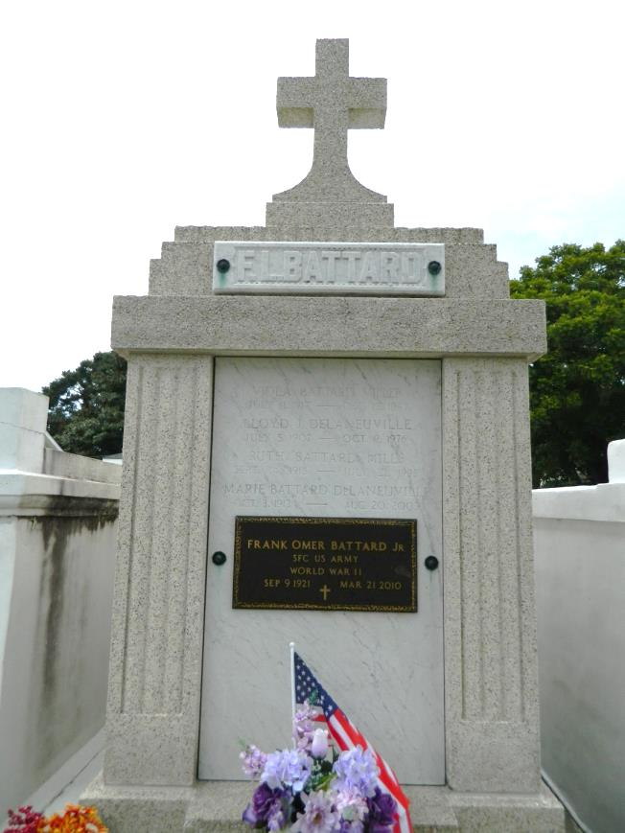

We are sad to announce the passing of Lotte Emma Baumann Battard on Wednesday, January 4, 2023 at the age of 96. She was born in Rauschwitz, Germany to the late Paul Baumann and Emma Baumann; sister of Gisela and the late Marto, Paul and Emma.

Lotte was a proud survivor of the Second World War as a civilian and refugee. After marrying the late U.S. Army Sgt. Frank Omer Battard and receiving her U.S. citizenship, she became a dedicated surgical technician. From there she made a career for over 50 years, where she made many lifelong friends. Lotte was determined and had resolve. She was an inspiration to everyone who wanted to learn what she could teach.  
 Beloved Mother of the late Frank Paul Battard Sr. (Patty) and of David Peter Battard (Liz). Grandmother of Frank Paul Battard, Jr. (Paula), Derek James Battard, Alexander Joseph Battard (Tracy), Jennifer Williams, Lauren Humphries (Dustin) and Austin Battard. She is also survived by many nieces, nephews, and great-grandchildren.  
 Relatives and friends are invited to attend the Visitation and Memorial Service at Millet-Guidry Funeral Home, 2806 W. Airline Hwy., LaPlace, LA on Friday, January 20, 2023. Visitation will be held from 9:00 a.m. to 11:00 a.m. followed by a Memorial Service at 11:00 a.m. Inurnment in St. Peter Cemetery, Reserve, LA.

Millet-Guidry Funeral Home, LaPlace, Louisiana

January 5, 2023