Sterling A. Bazile
September 15, 1957 - June 14, 2024

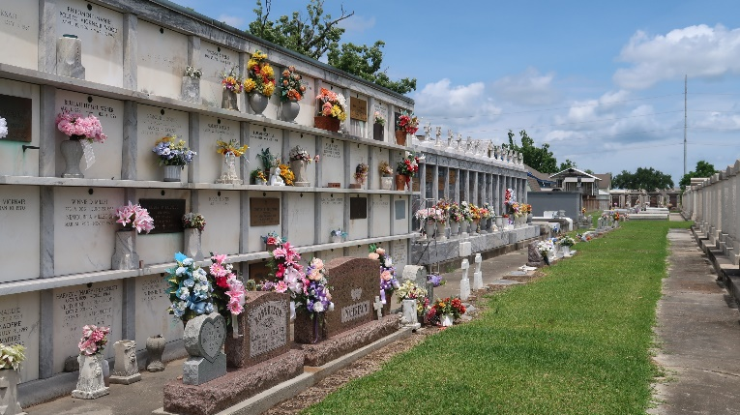

Sterling A. Bazile, a resident of Mt. Airy, LA departed to his heavenly home on June 14, 2024. Sterling was a football prodigy at an early age. He was a Leon Godchaux and LSU Football Star Defensive Tackle. A member of Leon Godchaux's Class of '76 and a 1980 graduate of LSU.
Beloved son of the late John and Juanita Bazile. He is survived by his siblings, Alice Thomas, Ronald Bazile, Linda B. Sami, Lydia B. Claudet (Adrian), Paul Bazile (Irene), Anna Bazile and Janice B. Harper.
He was preceded in death by his parents John and Juanita Bazile, brothers Johnny and Jessie Bazile, sisters Betty B. McGlown and Beverly B. White. He is also survived by a host of nieces, nephews, and other relatives and friends.
Priest and Parishioners of St. Hubert Catholic Church, relatives and friends of the family, Leon Godchaux High class of '76 and LSU teammates, former coaches and teachers, Turner Industries employees and neighboring churches are invited to attend a Mass of Christian Burial on Wednesday, June 26, 2024 at St. Hubert Catholic Church, 176 Anthony Monica St, Garyville, LA Visitation is from 9am until 11am service time. Entombment St. Peter Cemetery, Reserve, LA
Treasures of Life Funeral Services, Gramercy, Louisiana
July 4, 2024

