Doris Ann (Blank) Beadle
March 3, 1939 - August 23, 2023

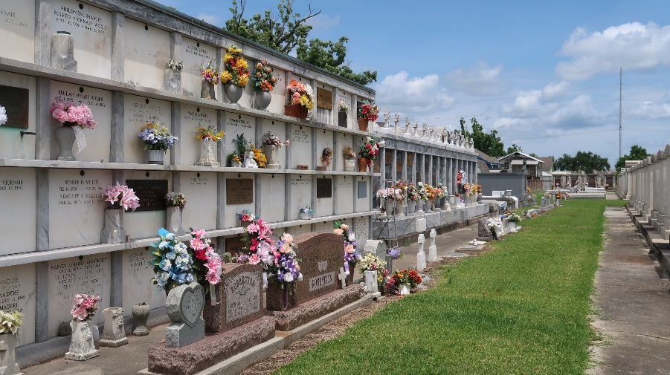

Our beloved Doris Ann Blank Champagne Beadle passed away peacefully in her sleep on August 23, 2023. She was born on March 3, 1939 in Gramercy, Louisiana.
She was preceded in death by her parents Felix and Lea Simon Blank, her husband Dudley Beadle, and her brothers Ralph, Donald, Felix Jr, and Barry Blank.
Left to remember her are her brother, Brother Ferrell Blank, her children Marianne Champagne Bloemer (John), Vicky Champagne Tamplain (Mark), Susan Champagne Oubre (Jessie), and Freddie Champagne, Jr. (Jennifer), grandchildren Erin Tamplain Obiol (Nathan), Alix Mury Pierce (Adam), Samantha Bloemer (Paul), Ellen Mury (Eric), Lea Champagne (Justin), and her great-grandchildren Lucy Obiol, Winter and Andrew Pierce.
The family thanks the staff and residents of Southeast Veterans Home in Reserve, Louisiana, for their care, support and friendship, Parishioners and friends at St Peter's Catholic Church in Reserve, Altar Society and AARP group.
Doris will be sadly missed by her family and numerous friends. She was always praying, socializing, and remembering everyone's birthdays. She had an amazing memory. She loved to cook, read, exercise, play bingo, go out to lunch and go to the 'casina'. She was cheerful and participated in everything she could, even on her last day with us. Rest now, sweet Doris.
Relatives and friends are invited to attend the Visitation and Funeral Mass at St. Peter Catholic Church, 1550 Hwy 44, Reserve on Monday, August 28, 2023 from 9:00 a.m. to 11:00 a.m. followed by a Funeral Mass at 11:00 a.m. Interment in St. Peter Cemetery, Reserve, LA.

Rose Lynn Funeral Home, Lutcher, Louisiana
August 26, 2023

