Edna (Vicknair) Becnel
February 1, 1916 – March 22, 2008

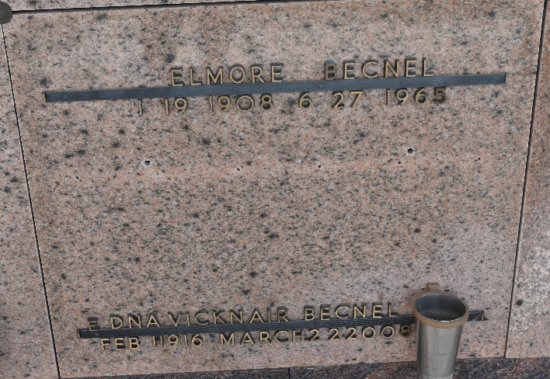

Edna Vicknair Becnel on Saturday, March 22, 2008 at 8:14 p.m. Beloved wife of the late D. Elmore Becnel. Mother and mother-in-law of Daniel E. Becnel Jr. and Mary Hotard Becnel, Robert M. Becnel and Diane Zink and Susan Becnel Williams. Grandmother of Daniel E. III, Devon, Bradley, Anisley and Ryan Becnel, Bridget Delivorias, Kelly Rovetto, Meghan Burns, Stephanie Barrett and Courtney Nickels. Great-grandchildren of Lawson, Mary Cannon and Anna Katherine Barrett, Phillip and Barron Delivorias, Jackson Rovetto, Jane, Christian, Nicholas and Thompson Becnel. Sister of Lucille Haydel, Percy Vicknair and the late Bernice Roth, Mae Montz, Minnie Mattei, Hazel Deslatte, Rose Lowry, Natalie Ramirez, Wilfred Vicknair. Age 92 years, a native of Garyville, La. and a resident of LaPlace, La. for the past 66 years.

Relatives and friends of the family are invited to attend services. Visitation at St. Joan of Arc Catholic Church, 529 W. 5th St., LaPlace, La. on Wednesday, March 26, 2008 from 9 a.m. to 11 a.m. Followed by Religious Services at the church at 11 a.m. Burial in St. Peter Cemetery, Reserve, La. In lieu of flowers, donations preferred to St. Joan of Arc Catholic Church, 529 W. 5th St., LaPlace, La. 70068. Arrangements by Millet-Guidry Funeral Home, LaPlace, La.
The Times-Picayune, New Orleans, Louisiana
March 25, 2008

