Henry M. Becnel Jr.

March 10, 1970 – May 16, 2014

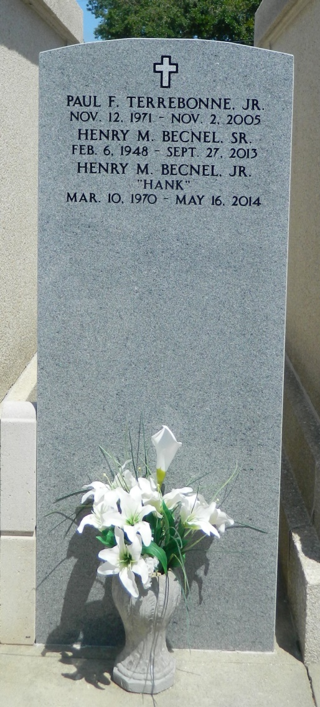

Henry M. Becnel Jr. passed away on Friday, May 16, 2014, at the age of 44 due to injuries sustained in a motorcycle accident.  
 He was the beloved husband of LaDonna Elledge, stepfather to Brooke Boudreaux (Dwayne), Sara Mullet (John Roy) and Kristian (Billy) Estes; grandfather of Madison Boudreaux, Myles Mullet, Braiden Estes, Mackenzie Estes and Dylan Wood; son of the late Henry M. Becnel Sr and Mary Dubre Becnel; brother of Gina B Grob (Chad), Aaron S. Becnel, Kerrie B. Cambre (Keith), Erica R. Becnel and the late Matthew J. Becnel. Other survivors include nephews, Joshua and Austin Becnel, Tyler Cambre, Peyton Terrbone and Ryder Grob. He will also be missed by his constant companion, his dog, Courage. He was a native of Reserve and a resident of Pittsburg, Pa.  
 Visitation will be at St. Peter Catholic Church in Reserve on Saturday, May 31, 2014, at 10 a.m., followed by mass at 11 a.m.  
 In lieu of flowers, donations preferred to Perry's Posse, a local organization for cancer patients, P.O. Box 2053, Garyville, LA 70051 or directly accepted at any First American Bank.

L'Observateur (La Place, LA) - Thursday, May 29, 2014

Contributed by Jane Edson