Henry M. Becnel Sr.

February 6, 1948 - September 27, 2013

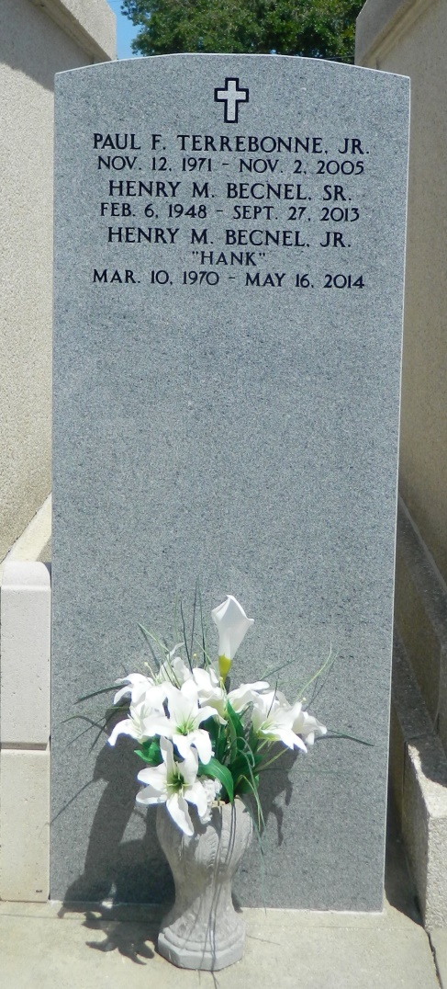

Henry M. Becnel Sr., 65, died Friday, Sept. 27, 2013.  
  
He was the beloved husband of Charlotte Piner Becnel, father of Henry Becnel Jr. (LaDonna), Gina B. Grob (Chad), Aaron S. Becnel, Kerrie B. Cambre (Keith), Erica Becnel, Rupert Morgan and the late Matthew J. Becnel, grandfather of Joshua and Austin Becnel, Tyler Cambre, Peyton Terrebonne, Isabella Morgan and Ryder Grob, son of the late Placide and Rita Becnel and brother of Herbert (the late Emily) and Jerry (Eva) Becnel. He was a native of Reserve and a resident of LaPlace.  
  
Services were held at St. Peter Catholic Church in Reserve on Monday, Sept. 30, 2013. Burial will be private at a later date.

L'Observateur (La Place, LA) - Tuesday, October 1, 2013

Contributed by Jane Edson