Marie Julie (Landry) Becnel
July 4, 1914 – September 22, 2005

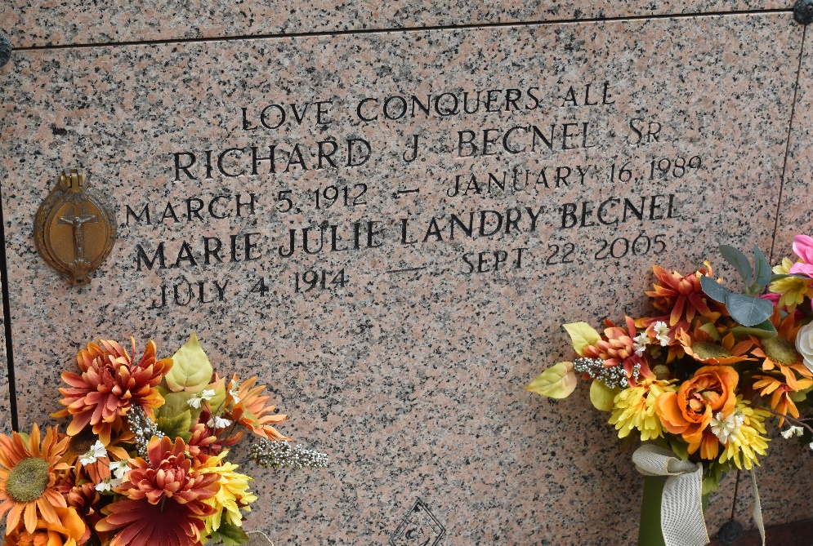

Becnel, Julie Marie Landry, a resident of La Place, Louisiana On Thursday, Sept. 22, 2005, at 2:25 p.m.
Julie Marie Landry Becnel, 91, of Reserve, died of complications from a stroke after an extended illness. She will be sadly missed by her children, grandchildren and great-grandchildren. She was preceded in death by her husband, Richard J. Becnel Sr. of Reserve; and son, Ronald R. Becnel.
Julie's life was dedicated to her Savior, the Lord Jesus Christ. She was lovingly devoted to her husband and she loved and cherished every member of her large and extended family. She was known for her exemplary kindness and love for all. It is with sadness that we mourn our loss, but yet we are filled with the joy of knowing that this wonderful lady joined her husband and son in peace with the Lord Jesus. We, her children, with much love and admiration, lift her up to the waiting arms of the Lord Jesus. Good-bye, Mom; we love you dearly!
Julie is survived by 11 children, 34 grandchildren and 44 great-grandchildren. Her children are Doris Rachel Becnel Credeur of Lafayette, who was married to the late Clifton Credeur, Richard J. Becnel Jr. of Austin, Texas, married to Jan Falls, Ellery J. Becnel of LaPlace, married to Joanie Rodrigue, Walter A. Becnel of Norco, married to GayNell Matherne, Robert H. Becnel of Reserve, married to Betty Simon, Joycelyn Becnel Bourgeois of Paulina, married to Mike Bourgeois, Jude Ann Becnel Deroche of Lutcher, married to Paul Deroche, Geraldine Becnel Samrow of Gramercy, married to Joe Samrow, Kay Becnel Lear of Lutcher, married to Bobby Lear Sr., Candy Becnel Pollet of Metairie and Gayle Becnel LeBoeuf of LaPlace, married to Wayne LeBoeuf. She will also be missed by Doris Braud Becnel, Sandra Stein Becnel Cortez and Greg Pollet.
Julie was the youngest child of Ferdinand Landry and Ernestine Parr of Convent, born on July 4, 1914. Her siblings, all deceased, were Phillip, Clement, Emile, Dennis, Ernest, Justine and Emily.
Visitation was at Millet-Guidry Funeral Home, LaPlace, on Sunday, Sept. 25, from 6 p.m. to 9 p.m. Visitation resumes at the funeral home on Monday from 8 a.m. to 9:45 a.m. Funeral service at St. Peter's Catholic Church, Reserve, at 10 a.m. Monday. In lieu of flowers, the family requests donations to St. Peter's Catholic School in Reserve.
Published on TheAdvocate.com on Sept. 26, 2005

