Lawrence J. Berthelot

July 18, 1945 – September 1, 2011

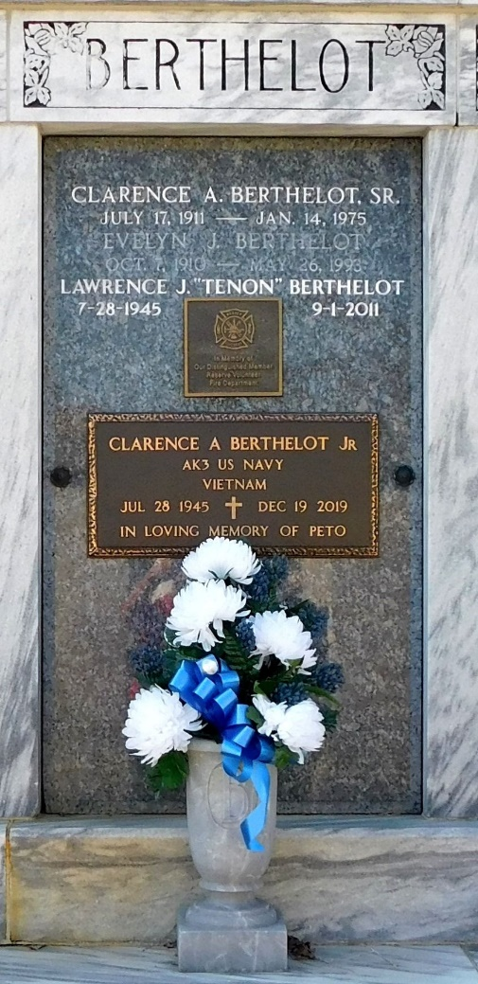

Photo by Mary Agnes Hammett

Lawrence (Tenon) Berthelot passed away on Thursday, September 1, 2011. Beloved husband of Evette Trosclair Berthelot. Son of the late Clarence and Evelyn Jacob Berthelot. Brother of Robert (Bob) (Carla), Clarence Jr. (Peto) (Mary) and the late Alan (Eboo) (Mary Lee) Berthelot. Godfather of Cindy Faucheaux, Cary and Travis Berthelot and Joey Marse. Also survived by numerous brother and sister in laws and nieces and nephews.

He was a charter member of Reserve Volunteer Fire Department, life-time member of the Knights of Columbus and a St. John Auxiliary Police Officer. Age 66 years. A native and resident of Reserve, LA.

Relatives and friends are invited to attend services. Visitation at Millet-Guidry Funeral Home, 2806 W. Airline Hwy., LaPlace, on Monday, September 5, 2011 from 5:00PM until 9:00PM and on Tuesday from 8:00AM until 9:30AM followed by a Mass at St. Peter Catholic Church, Reserve at 10:00AM. Burial in St. Peter Cemetery, Reserve.

The Times-Picayune, New Orleans, Louisiana

September 2, 2011