Rosalie (Robert) Bienvenu
February 17, 1918 – November 21, 2012

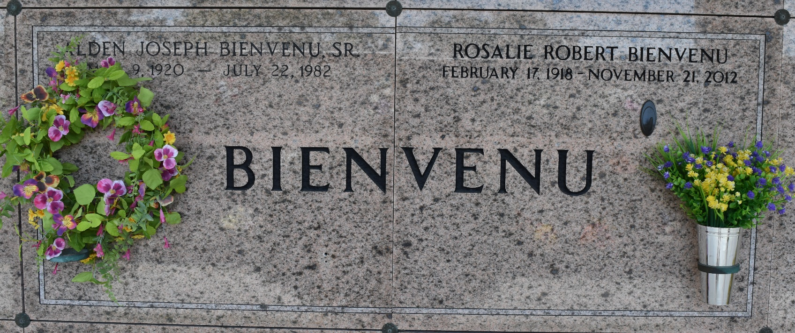

Rosalie Robert Bienvenu died peacefully on Wednesday November 21, 2012. Rose was born on February 17, 1918 in Luling, LA. She was preceded in death by her loving husband, Alden Joseph Bienvenu. Rose and Alden were the parents of Janis Bienvenu, (Tom Marinaccio), Cathy Waldrup (Tom), Alden J. Bienvenu Jr., (Peggy), Suzy Bologna (Russell) and Elly Langley (Robert). Rose was the adored grandmother of Adele Bienvenu Tiblier, Matthew Ryan Waldrup, Robert "Robbie" Langley II, Katie Graham Klibert, Chad Michael Waldrup, Jennifer Catherine Langley, Jessica Langley Knoy, Alexis Graham Turner and Tony Marinaccio. Her smiling face and generous heart will also be missed by her great-grandchildren Bryce Michael Cason, Rylie James and Jayslin Elizabeth Langley, Trey Alden and Sydney Shae Knoy, Aiden Joseph Tiblier, Richard "Trip" Gary Klibert III, Aubrey Jolie Waldrup, Lee Alden Waldrup, and Sophia, Stella, Olivia and Dominic Bologna. Her family is grateful that Rose could share the love and attention of her sole surviving sibling, Beatrice Maurin.
Rose was preceded in death by her parents, James and Pearl Zeringue Robert, and sisters, Pearl LeBlanc, Ruby Guidry, Emma Mae Bourgeois, and brothers James, Marion, Ray and John Warren Robert. Age 94. A native of Ama, LA and a resident of Reserve, LA. The family would like to thank her devoted caregivers, Gloria Alexander, Gretchen Feldier & Johonna Triche.
Relatives and friends are invited to attend services. Visitation at St. Peter Catholic Church, Reserve, LA on Saturday November 24, 2012 from 11:00am to 12:00pm, followed by Mass at 12:00 noon. Interment in St. Peter Cemetery.
Published in TheAdvocate.com from Nov. 22 to Nov. 23, 2012

