Helen (Weber) Blouin
January 14, 1934 – January 26, 2014

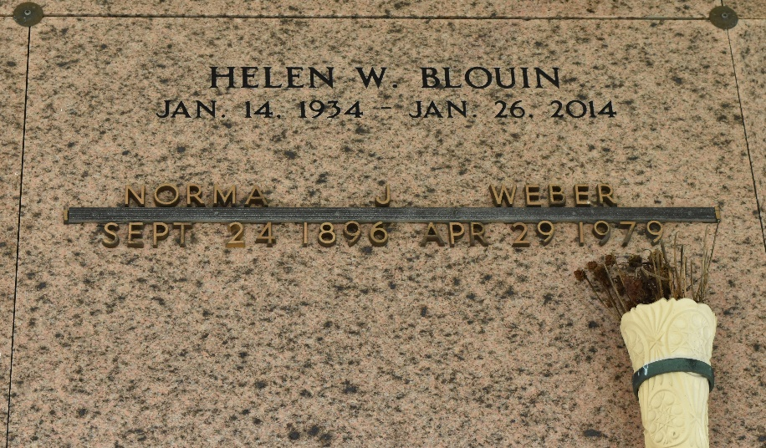

Helen Weber Blouin died on Sunday January 26, 2014. Beloved mother of Debbie Cobb (Larry), Emily Blouin Toups (Jimmy), Gary (Terri), Bruce (Laura, deceased), Darryl (Liz), Timmy (Liz, deceased) and Dale Blouin. Also 11 grandchildren and 6 great-grandchildren.
Daughter of the late Noe and Norma Jacob Weber. Sister of Earline Mollere and the late Jules, Norman, Hayes and Howard Weber and Noelie Breaud. Age 80. A native of Reserve and resident of LaPlace, LA.
Relatives and friends are invited to attend services. Visitation at Millet-Guidry Funeral Home, 2806 W. Airline Hwy., LaPlace, LA. on Monday February 3, 2014 from 8:00am to 10:00am, followed by Religious Services in the Funeral Home Chapel at 10:00am. Burial in St. Peter Cemetery, Reserve, LA.

The New Orleans Advocate (Louisiana)
Jan. 31 to Feb. 3, 2014

