Amy (Brou) Boe

June 21, 1904 – October 26, 1999

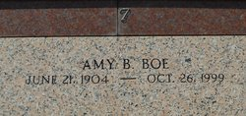

Photo by Team T-Lo

LAPLACE - Amy B. Boe, 95, a native of Edgard and resident of Reserve for75 years, died Oct. 26. She was the wife of the late Horace Boe and mother of Abner, Earl, Melvin and the late Lloyd Haydel. She is also survived by numerous grandchildren and great-grandchildren.

Services were held Oct. 28 in the chapel of Millet-Guidry Funeral Home, LaPlace, with interment at St. Peter Cemetery, Reserve.  
  
L'Observateur, LaPlace, Louisiana

October 30, 1999