Beatrice Marie (Waguespack) Boe
February 4, 1925 – June 24, 2013

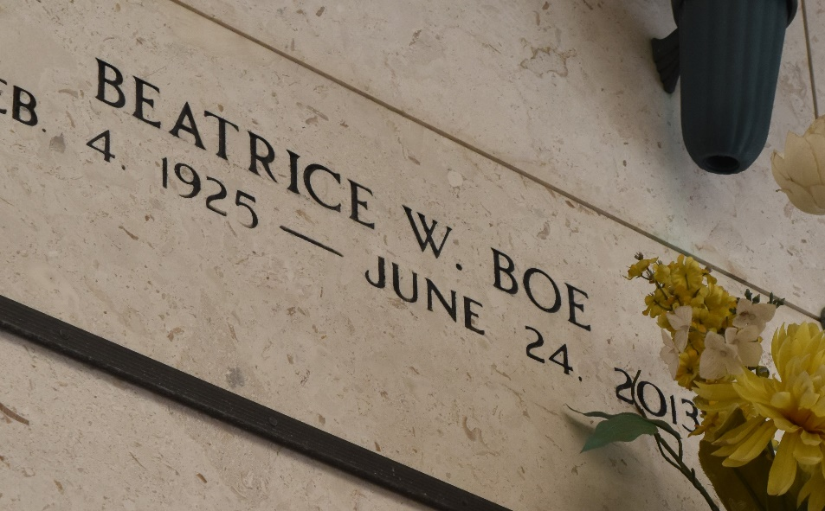

Beatrice Waguespack Boé died on June 24, 2013. Beloved wife of the late Caire A. Boé. Mother of Caire Boé Jr., (Emma) and Mark Boé. Grandmother of Theresa Williams, Leon Boé, Mary Margaret Mosakowski, Paul Boé, Craig Boé, Bridgette O'Connor and Alex Boé. Great-grandmother of Ansley, Joshua, Kathryn, Grace, Emily, Nolan and Finn. Sister of Rona Klibert. Age 88.
A native and resident of Reserve, LA. She was a longtime employee of Reserve Lumber Yard.

Relatives and friends are invited to attend services. Visitation at Millet-Guidry Funeral Home, 2806 W. Airline Hwy., LaPlace, LA on Thursday June 27, 2013 from 5:00pm to 9:00pm and on Friday 8:00am to 9:30am, followed by Mass at St. Peter Catholic Church, Reserve, at 10:00am. Burial in St. Peter Cemetery.

The Advocate, Baton Rouge, Louisiana
Jun. 25 to Jun. 27, 2013

