Caire A. Boe

September 27, 1919 – January 3, 2003

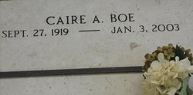 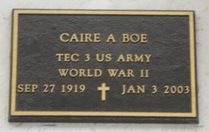

Photos by Team T-Lo

Caire A. Boe', On Friday, January 3, 2003 At 3:15 P.M. Beloved Husband Of Beatrice Waguespack Boe'. Father And Father-In-Law Of Caire Boe', Jr. And Emma Boe' Of Tampa, Fl And Mark Boe' And Rhonda Boe' Of Reserve, La. Grandfather Of Terri Boe' Williams, Leon J., Mary Margaret, And Paul Boe', Also Craig, Bridgette A., And Alex M. Boe'. Son Of The Late Raoul And Euphemie Tassin Boe'. Brother Of Ray Boe', Elma Leblanc, Elizabeth Guidry, Jeanne Keller, And The Late Raoul 'Bobby' And Alvin Boe', And Martha Fourroux.  
 He Was A Retiree Of Shell Oil Norco Refinery And A Veteran Of World War II. Age 83. A Native Of Mt. Airy And A Resident Of Reserve For The Past 56 Years.  
 Relatives And Friends Of The Family, Also Members Of Monsignor Eyraud Knights Of Columbus Council No. 2436 And American Legion Are Invited To Attend Services. Visitation At Millet-Guidry Funeral Home, 286 West Airline Hwy., Laplace On Sunday, January 5, 23 From 5: P.M. Until 9: P.M. And On Monday, January 6, 23 From 8:3 A.M. Until 9:45 A.M. Followed By Religious Services At St. Peter Catholic Church In Reserve At 1: A.M. Burial In St. Peter Cemetery In Reserve.  
  
Times Picayune, New Orleans, Louisiana

January 5, 2003