Floyd Joseph Boe
January 2, 1929 – September 26, 2017

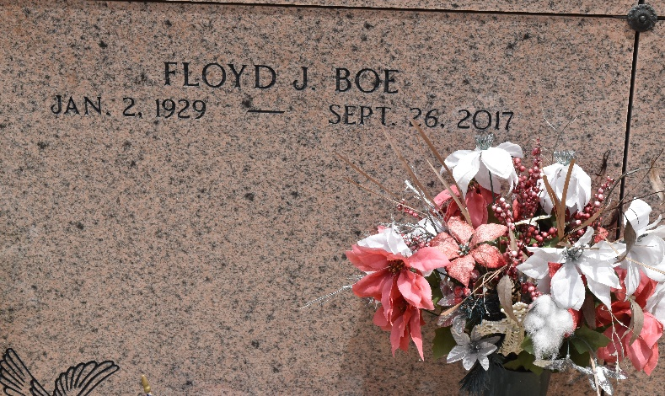

Floyd Joseph Boe passed away at his residence on Tuesday, September 26, 2017 at the age of 88. He was a native and resident of Garyville, LA. Floyd served in the U.S. Marine Corps Reserve and later worked as an operator for Godcheaux Sugar Refinery, security guard for Rollo Security and was a self employed janitor.
Beloved husband of Gloria Landry Boe. Father of Audie Boe (Barbara), Sue Brignac (Randy), Melissa Abreo (Tommy Jr.) and Alicia Smith (Ryan). Grandfather of Wesley Gage, Tammy Boe, Amber Leblanc, Shaun Brignac, Blake Abreo and Destiny Smith. He is also survived by 11 great grandchildren and 4 great great grandchildren.
He was preceded in death by his parents, Wallace Boe and Antoinette Leroux Boe and a brother, Charles Boe (Lois).
Relatives and friends are invited to attend the visitation and Funeral Service at Millet-Guidry Funeral Home, 2806 W. Airline Hwy., LaPlace on Thursday, September 28, 2017 from 11:00 a.m. until 2:00 p.m. followed by the Funeral Service at 2:00 p.m. Interment to follow in St. Peter Cemetery.
Millet-Guidry Funeral Home, LaPlace, Louisiana
September 27, 2017

