Richard Nolan Boneno
October 1, 1924 - March 8, 2024

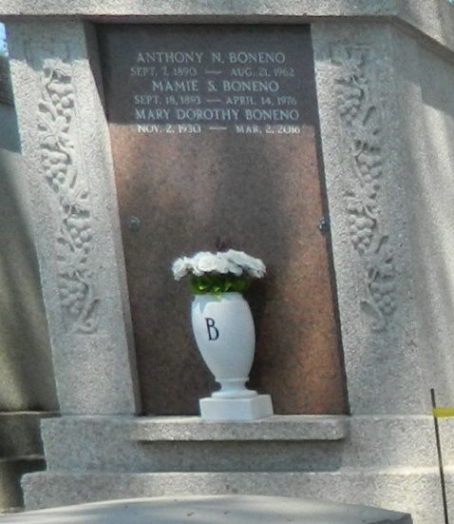

Richard Nolan Boneno passed away on March 8, 2024 at the age of 99. A native of Garyville, La., he was the son of the late Anthony N. Boneno and Mamie S. Boneno, brother of the late Luke A. Boneno and the late Mary Dorothy Boneno, brother-in-law of the late Anna Belle Dupre Boneno. He is survived by nephews Barry Boneno and Gary Boneno, Nieces Patricia Gilleland and Pamela Justice, many great nieces and nephews and his friends and caretakers Bill and Diane Hodges.
A veteran of World War II, he served 1 year in GENED, an Army Corps. of Engineers group under General Douglas MacArthur, Commander of U. S. Armed Forces in the Far East, organized specifically to rebuild the war-torn city of Manila, arriving in the Philippines during the battle of Manila south of Japan when the atomic bombs were dropped ending WWII.
He received his B.A. Degree from Southwestern at Lafayette, his M.A. Degree in Art Education from LSU. He did further work in the Art Dept. of Colorado University at Boulder, and at three summer sessions with Louisiana Tech in Rome, Italy. He taught at Leon Godchaux High School in Reserve where in 1954 he began the first scheduled art class in the St. John Parish school system. As a member of the Carnival Ball Committee, he designed several backdrops for the yearly balls. During a Sabbatical at LSU he taught classes on an Assistantship in the Art Dept. Following the fire that destroyed Leon Godchaux high he taught at East St. John until retirement. His paintings and prints were exhibited at the Baton Rouge Art Guild and many state and regional shows, and he is represented by a Collagraphic print in the Louisiana State Art Collection in Baton Rouge. During his teaching career he wrote sixteen articles on school art projects illustrated with his students’ art work which were published in three national school arts journals.
With a life-long interest in travel and photography he visited and took photographs in many countries in Europe, Africa, and South America. In 1965 he returned to Manila to visit the area where he was stationed during the War. From there he continued on a world tour, traveling from Japan through India to Israel and Egypt where he went down into King Tut’s Tomb before ending his trip at the World’s Fair in New York City. When China opened the country to western tourists, he was among the first Americans to visit many inland Chinese cities. He later won first prize in a national contest, a trip to England, with a photo he had taken in Beijing.
Relatives and friends are invited to attend the Funeral Service at Millet-Guidry Funeral Home, 2806 W. Airline Hwy, LaPlace on Monday, March 18, 2024. Visitation will be held from 9:00 a.m. to 11:00 a.m. with the Funeral Service to immediately follow at 11:00 a.m. Burial to follow in the the Boneno family tomb in St. Peter Cemetery, Reserve, LA.

Millet-Guidry Funeral Home, LaPlace, Louisiana
March 9, 2024

