Eula (Roger) Borne

September 4, 1924 – October 5, 2018

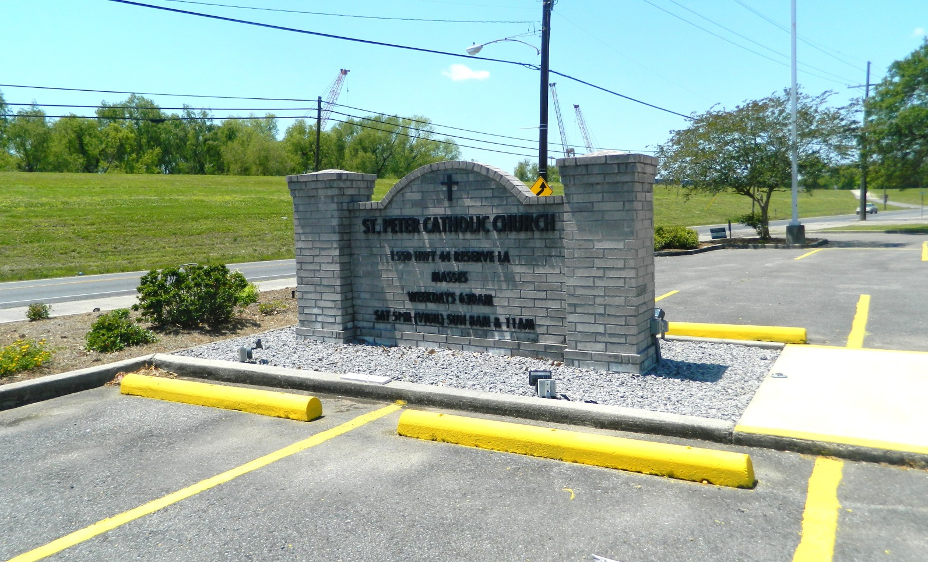

Eula Roger Borne passed away on Friday, October 5, 2018. She was 94, born in Thibodaux, LA and was a resident of Reserve, LA. Beloved wife of the late Etienne J. Borne. Mother of Elizabeth ‘Liz’ Garcich (husband, Blaine). Grandmother of Ashley and Heidi Garcich. Great-grandmother of Autumn Garcich. Sister of Ouida R. Faucheux. Daughter of the late Helen Clement Roger and Leo Roger. Sister of the late Earline Gaubert, Ruby Richard, Florence Pitre, Doris Bourgeois and Malvin, Earl, Algi and Milton Roger. Also survived by many nieces and nephews. Eula was a loving wife, mother, grandmother, mother-in-law, sister and aunt. She will be sadly missed by all who loved her.

Relatives and friends are invited to attend the Funeral Mass at St. Peter Catholic Church, 1550 Hwy 44, Reserve on Tuesday, October 9, 2018 11:00 a.m. Visitation will begin in church at 9:00 a.m. Interment in St. Peter Cemetery. Arrangements by Millet-Guidry Funeral Home

Millet-Guidry Funeral Home online obit (accessed 10/7/2018)