Gloria (LeBouef) Borne

February 3, 1927 – April 17, 2009

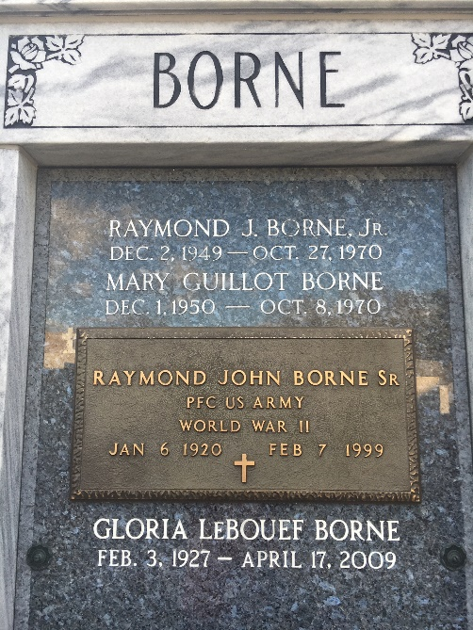

Photo by Team T-Lo

A resident of Garyville, Gloria LeBouef died on Friday, April 17, 2009, at age 82.  
 She was married for 51 years to Raymond John Borne Sr., who preceded her in death. She is survived by a huge, loving family: daughters, Gwen Becnel, Peggy Lambert, Donna Dicharry, Kay Morvant and Nancy Bourgeois; son, William "Billy" Borne; sisters, Willa Mae Wilson and Clara Belle Foster; 18 grandchildren and 13 great-grandchildren.  
 Also preceded in death by her father and mother, Willie and Edna LeBouef; brothers, Willie, Felix and Lawrence "Pete" LeBouef; and son, Raymond J. Borne Jr.  
 She led a life dedicated to serving the Lord and was a role model to all. Relatives and friends are invited to attend the visitation and funeral Mass at St. Hubert Catholic Church, Garyville, on Monday, April 20. Visitation is from 9 a.m. to 12:45 p.m. with the Mass following at 1 p.m. Interment in St. Peter's Cemetery.  
  
The Advocate, Baton Rouge, Louisiana

April 18 to April 19, 2009