Helen May (Waguespack) Borne
May 23, 1927 – March 20, 2019

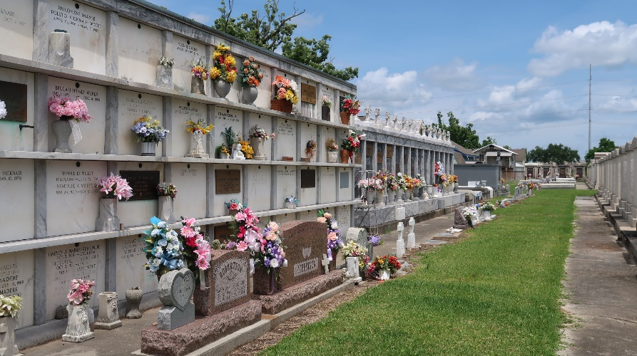

Helen Waguespack Borne, a native of Reserve and resident of Baton Rouge passed away Wednesday, March 20th 2019 at the age of 91.
She is survived by her sons Stanley and Dennis Borne (Denise); daughters, Paulette Virnich, Judy Hartmann (Don), Amy Ryan (Gene); sisters, Irene Monica and Caroline Monroe; brother, Walter Waguespack; grandchildren, Holly Millet, Jason, Michael, and Elizabeth Borne; Matt and Mark Virnich, Anne Freeman and Katie Harrison; Heather Bagala; Jessica Loupe and Ashley Brown; Courtney Bramley, Whitney, Anne-Marie, and Benjamin Ryan. She is also survived by great-grandchildren; Brittany; Bryson and Brianna; Bentley and Baylen; Gabriel and Samuel; Anthony and Micah; Madelyn, Matthew, Miley, and Michael; and Kamryn and Jonah.
She was preceded in death by her husband, Whitney Borne, Sr.; son, Whitney Borne Jr.; parents, Benjamin & Marie Waguespack; brother, Benjamin Waguespack, Jr.; grandson, Stanley Borne Jr. and son-in-law, Tom Virnich.
Visitation will be on Saturday, March 23, 2019 from 10:00 am until a Mass of Christian burial at 12 pm at St. Peter Catholic Church in Reserve, LA. Burial will be in the church cemetery.

Rose Lynn Funeral Home, Lutcher, Louisiana

