Raymond John Borne Jr.

December 2, 1949 – October 27, 1970

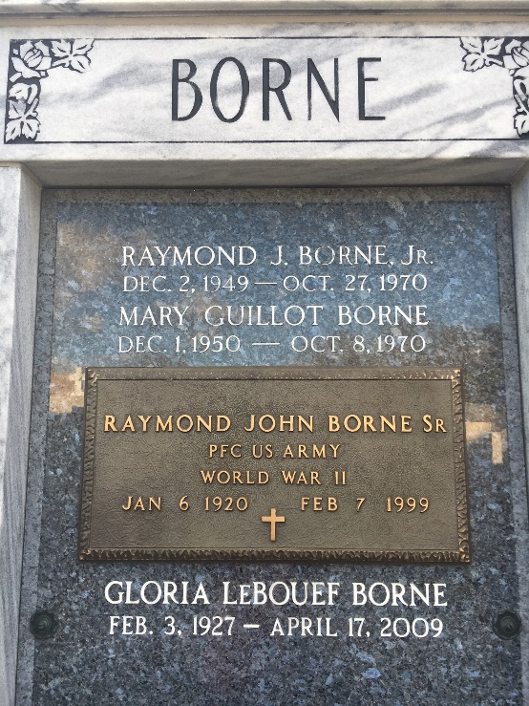

Photo by Team T-Lo

Raymond Borne Dies of Accident Injuries

Funeral services for Raymond J. Borne, Jr., 21, will be held at 11 a.m. Thursday, October 29, with religious rites at the St. Hubert Catholic Church in Garyville and interment in St. Peter Cemetery, Reserve.

Mr. Borne died in Our lady of the Lake Hospital in Baton Rouge at 9 p.m. Tuesday, October 27, of internal injuries received in an automobile accident in which his wife, the former Mary Catherine Guillot, 19, of Laplace, was killed.

Mr. Borne had been in the hospital since the accident, which occurred about 8 p.m. October 8 when a woman driving the wrong way on the I-12 Expressway in Baton Rouge collided headon with the car he was driving.

The driver of the car, Mrs. Clvola P. Nettles, 49, Baker, had been booked with negligent homicide in connection with the accident, state police said.

Both Mr. Borne and his wife were students at Louisiana State University in Baton Rouge and both were valedictorians of their graduating classes the Leon Godchaux High School in Reserve, Mr. Borne in 1967 and Mrs. Borne in 1969.

Surviving Mr. Borne are his parents, Mr. and Mrs. Raymond J. Borne, Sr., of Garyville; a brother, William (Billy) Borne; five sisters, Mary Gwendolyn, Peggy Ann, Donna Elizabeth, Kay Theresa and Nancy Ann Borne, and his paternal grandmother, Mrs. John Borne of Garyville.

Funeral arrangements are being handled by the Alexander Funeral Home in Lutcher.

L’Observateur, LaPlace, Louisiana

Thursday, October 29, 1970, p. 23