Thelma (Hoover) Borne
August 1, 1937 – November 28, 2011

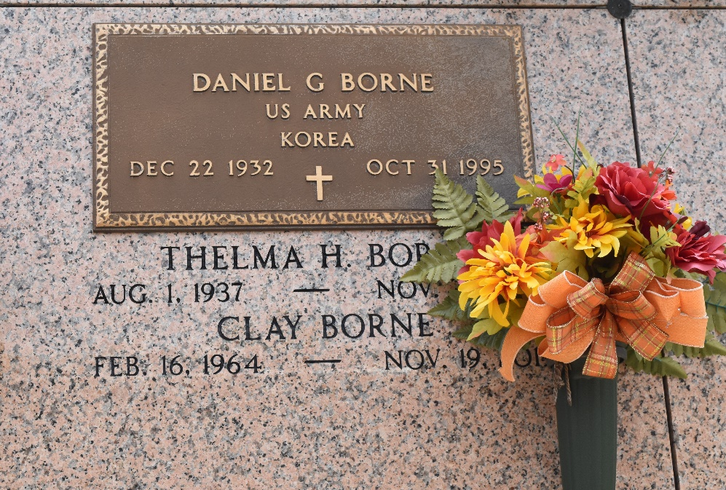

Thelma Hoover Borne passed away on Monday November 28, 2011. Beloved wife of the late Daniel (Pappy) Borne. Mother of Kathy Brasington (Doug), Clay Borne (Rasa) and Brett Borne. Grandmother of Hailee and Brice Brasington. Daughter of Eve Decota Hoover and the late Robert Hoover. Sister of Wayne Hoover, Roberta Simon, Judy Devall and Mary Wolford. Age 74. A native of Ponchatoula, LA and a resident of Reserve, LA.
Relatives and friends are invited to attend services. Visitation at Millet-Guidry Funeral Home, 2806 W. Airline Hwy., LaPlace, LA on Thursday December 1, 2011 from 5:00 pm to 9:00 pm and on Friday from 8:00 am to 9:30 am, followed by Mass at St. Peter Catholic Church, Reserve, LA at 10:00 am. Burial in St. Peter Cemetery.
Unknown source

