Kathleen (Karrer) Bossier
Abt. 1960 – June 6, 2024

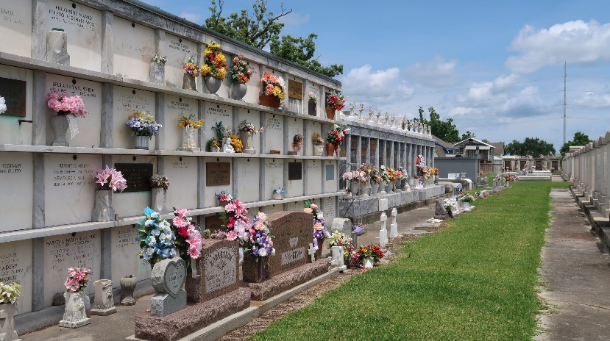

Kathleen "Kathy" Karrer Bossier passed away on Thursday, June 6, 2024 at the age of 64 at her home. She was born in New Orleans, LA and was a resident of Reserve, LA.
Kathy, also known as “Queenie”, was the loving and beautiful wife of Leroy “Mike” Bossier and the love of his life for 40 years. She was a wonderful mother to Kristy Robertson Jones (Bruce) and the late Randy Paul Robertson (Kelly) and second mom to Kandee Jacobs. Kathy was always there when they needed her the most offering support, wisdom, and love in abundance. Grandmother of Payton Michael Jones, Kalleigh Lynn Jones, Jordyn Robertson, Brooklyn Robertson, Bryce Robertson, Carolyn Robertson and the late Brett Michael Robertson, which were her life. She truly lived for her grandkids. Kathy was also an amazing Nurse. Daughter of the late Josephine Becnel Karrer and George Karrer.
If you knew her; you loved her. Kathy will be greatly missed by all. She has gained her angel wings and now is in heaven with her son, grandson, and parents.
Relatives and friends are invited to attend the Visitation and Funeral Mass at St. Joan of Arc Catholic Church, 529 West 5th Street, LaPlace on Monday, June 10, 2024. Visitation will be held at the church from 10:00 a.m. to 12:00 p.m. followed by a Funeral Mass at 12:00 p.m. Interment in St. Peter Cemetery, Reserve, LA. A repass will be held after the services at the KC Hall in LaPlace, LA.

Rose Lynn Funeral Home, Lutcher, Louisiana
June 11, 2024

