Jonathan Ory Boucvalt
March 12, 1981 - July 3, 2024

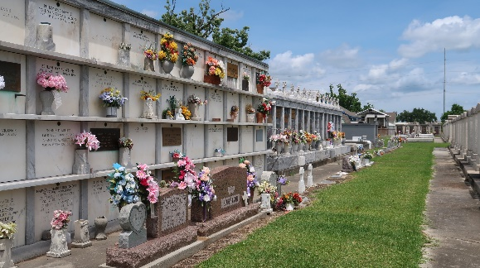

Jonathan Ory Boucvalt, 43, of LaPlace, passed away, July 3rd, and is now resting peacefully in Heaven. He was born March 12, 1981. Jonathan lived a sweet life with his loving partner, Kayla Cyrier.
Remaining to honor Jonathan’s memory are his Beloved Children, Brody, Emorie, and Cam; Parents, Jobé and Anne Boucvalt; Brothers, Christopher (Lesli), Benjamin (Valerie), Matthew (Maria), and Andrew (Caroline); Sister, Emilie (Andrew); Kayla’s Parents, Randy and Debbie Soileau; as well as a niece and multiple nephews.
Jonathan lived a spirited life, leading with love and light. In these hard times, he encourages us all to live in such a way. To think of him not with thoughts of sorrow, but with the joy he made us all feel.
Relatives and friends are invited to attend the Visitation and Memorial Mass at St. Joan of Arc Catholic Church, 529 W. 5th St., LaPlace on Tuesday, July 16, 2024. Attire: bright colors encouraged. Visitation will be held at the church from 9:00 a.m. to 12:00 p.m. followed by a Memorial Mass at 12:00 p.m. Inurnment in St. Peter Cemetery, Reserve, LA.

Millet-Guidry Funeral Home, LaPlace, Louisiana
July 11, 2024

