Henry Anthony Boudreaux
October 31, 1914 – March 2, 1963

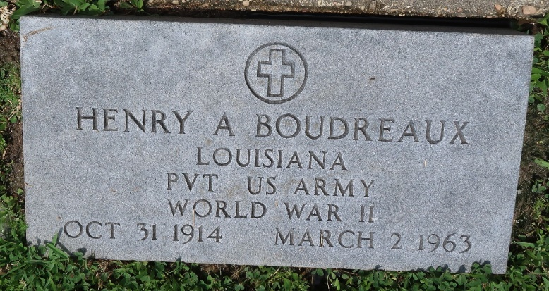

BOUDREAUX – On Saturday, March 2, 1963, at 8:20 o’clock a.m. Henry Anthony Boudreaux, son of the late Amelia Gautreaux and Leon Boudreaux, brother of Sidney Boudreaux of Baltimore, Md., Mrs. Russell Dodds of Victoria, Tex., and Prosper Boudreaux. Age 48 years; a native of Montz, La., and a resident of Norco, La.
Relatives and friends of the family, also employes of Shell Oil Co., Norco, La., are invited to attend the funeral. Services from the Alexander Funeral home, Norco, La., on Monday, March 4, 1963, at 9:30 o’clock a.m. Religious services at the Sacred Heart of Jesus Church, Norco, La. Interment in St. Peter’s Cemetery, Reserve, La. Parlors will be open Sunday at 2 o’clock p.m.

Unknown newspaper clipping

