Agnes (Vicknair) Bourgeois
January 21, 1905 – January 15, 1999

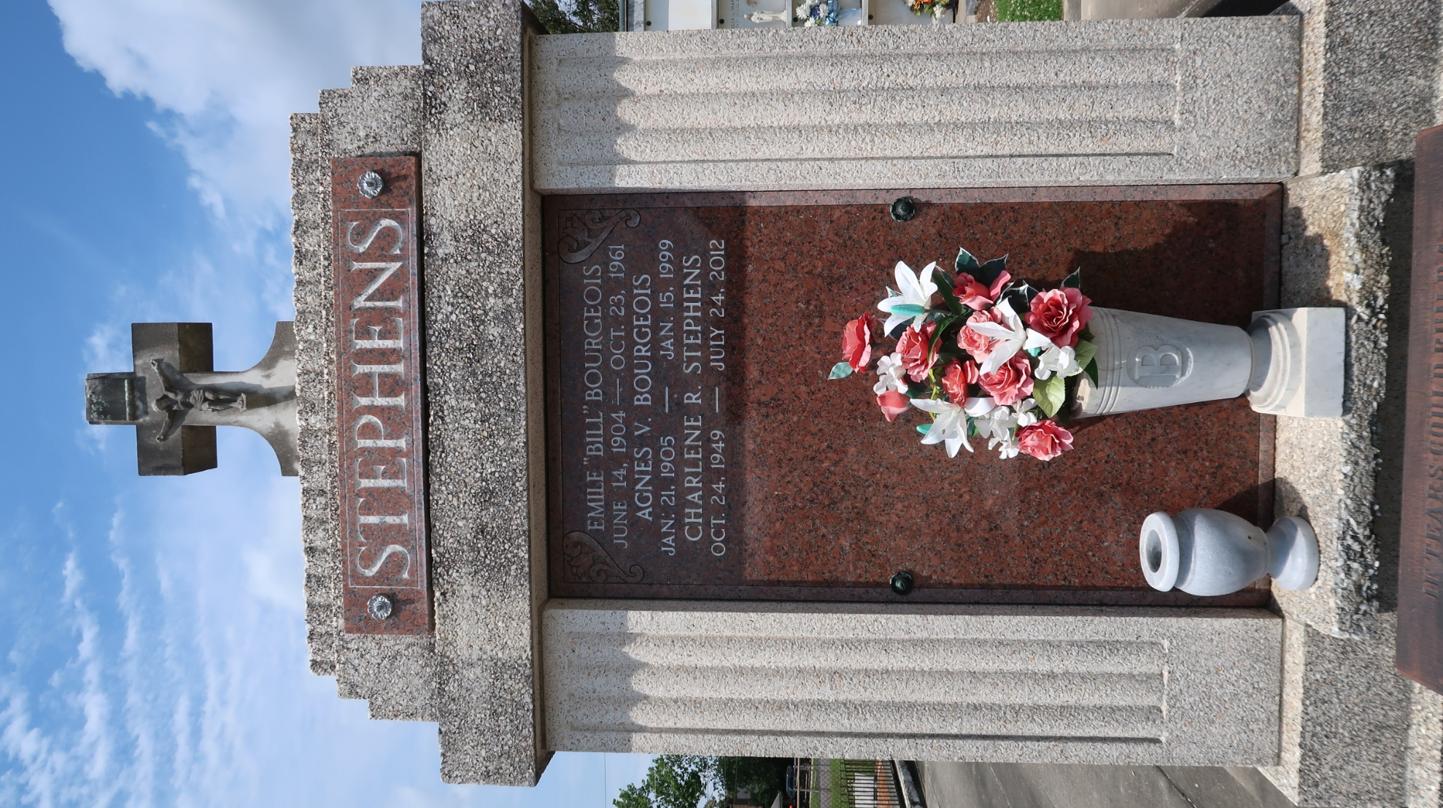

LAPLACE - Agnes V. Bourgeois, 94, a native and resident of Reserve, died Jan. 15. She was the wife of the late Emile Bourgeois. She was also the daughter of the late Aristide and Gustavie Vicknair and sister of Mae Roussel and the late Edgar, Henry and Clinton Vicknair.
Services were held Jan. 18 in the chapel of Millet-Guidry Funeral Home, LaPlace, with interment at St. Peter Cemetery, Reserve.
L'Observateur, LaPlace, Louisiana
January 20, 1999

