George M. Bourgeois
March 8, 1855 – January 2, 1941

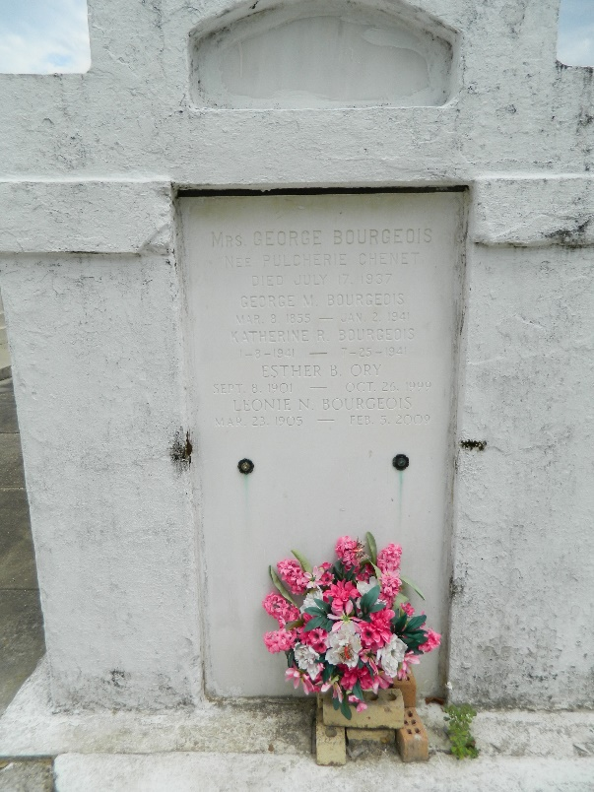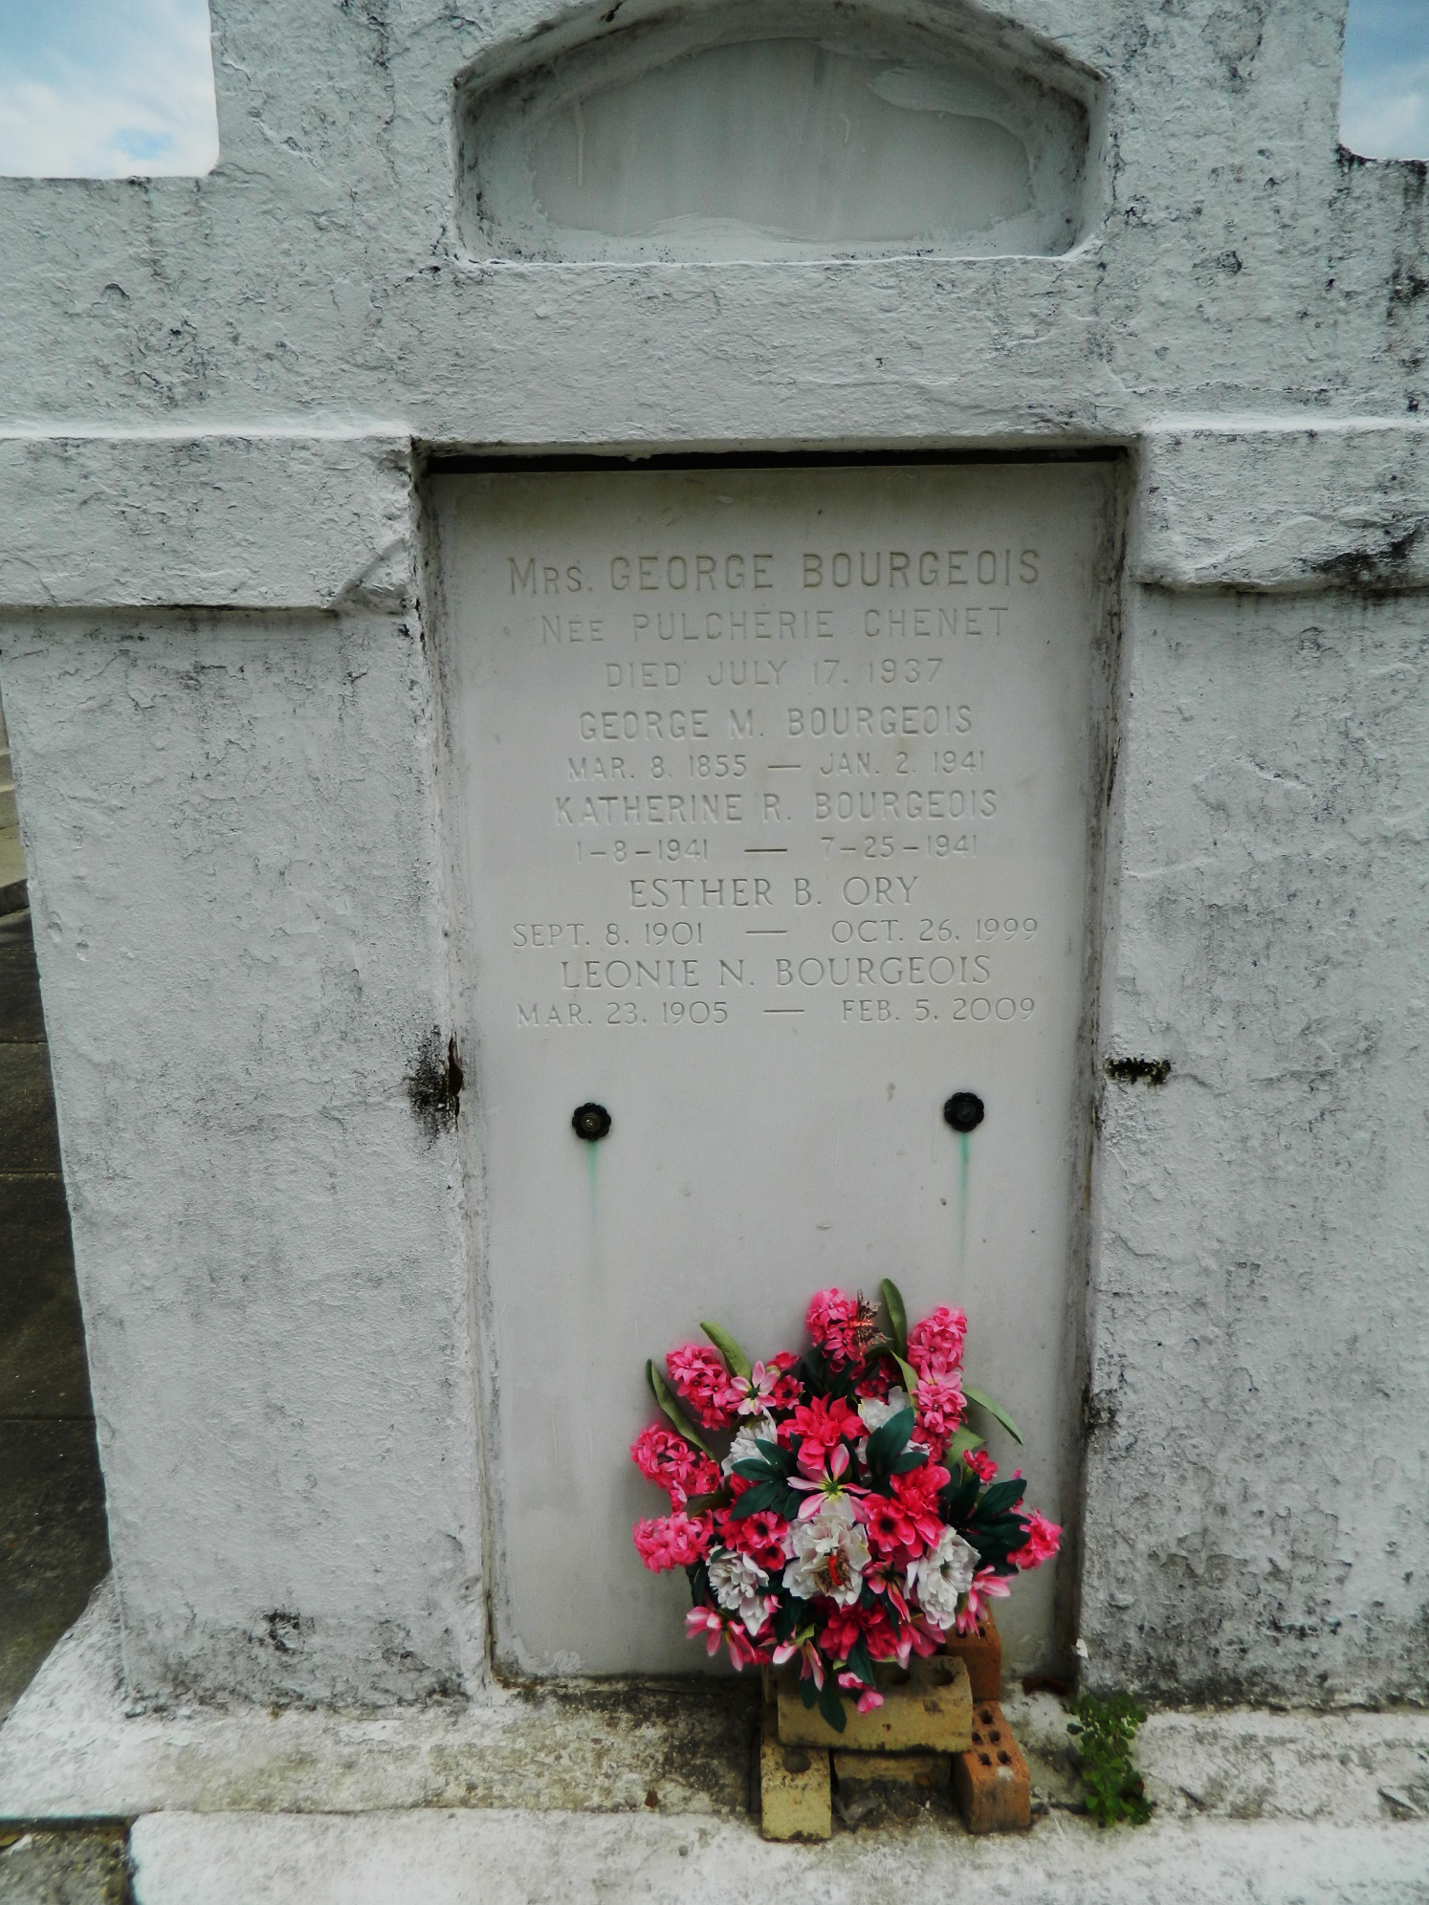

George M. Bourgeois was born in Mt Airy, Louisiana, on 8 Mar 1855 to Thomas and Mary Picou Bourgeois. He received his early education at a private school near his home and graduated from Jefferson College in St James Parish in 1878 with an A. B. degree. He began his commercial life at age 24 years as a clerk in a mercantile house in St John the Baptist Parish but after 6 months in this business, he formed a partnership business in Mt Airy with his sister, Mrs. Tanguis. This business prospered and was continued under the original arrangement for about 15 years when the partnership was disolved and he formed a successful mercantile business in Garyville, Louisiana, under his own name.
Mr. Bourgeois affiliated with the democratic party and served his neighbors in various official capacities, occupying the office of Justice of the Peace about 12 years, and being a member of the Police Jury of the parish about the same length of time. He was a member of the Catholic Church and of the Imperial Order of Red Men.
In the year 1881 he married Louise Tregre, daughter of Alcide Tregre and Odile Triche Tregre. Mrs. Bourgeois died in 1885 leaving no children and he married on 20 Oct 1896 to Pulcherie C. Chenet of St. John the Baptist Parish. Six children were born of this union: Elmore George, Georgette who died in infancy, Ethel L., D'Aquin H., Leonie N. and Marie Antoinette who died at age 2 years. George M. Bourgeois died at Garyville on Thursday 2 Jan 1941 at 1:20 p.m. at age 85 years. Religious services Friday 3 Jan 1941 at St. Hubert Church, Garyville, with interment in St Peter Cemetery, Reserve, Louisiana.

Contributed by Dwayne Montz

