Lola Ann (Mitchell) Bourgeois

July 2, 1932 – July 31, 2000

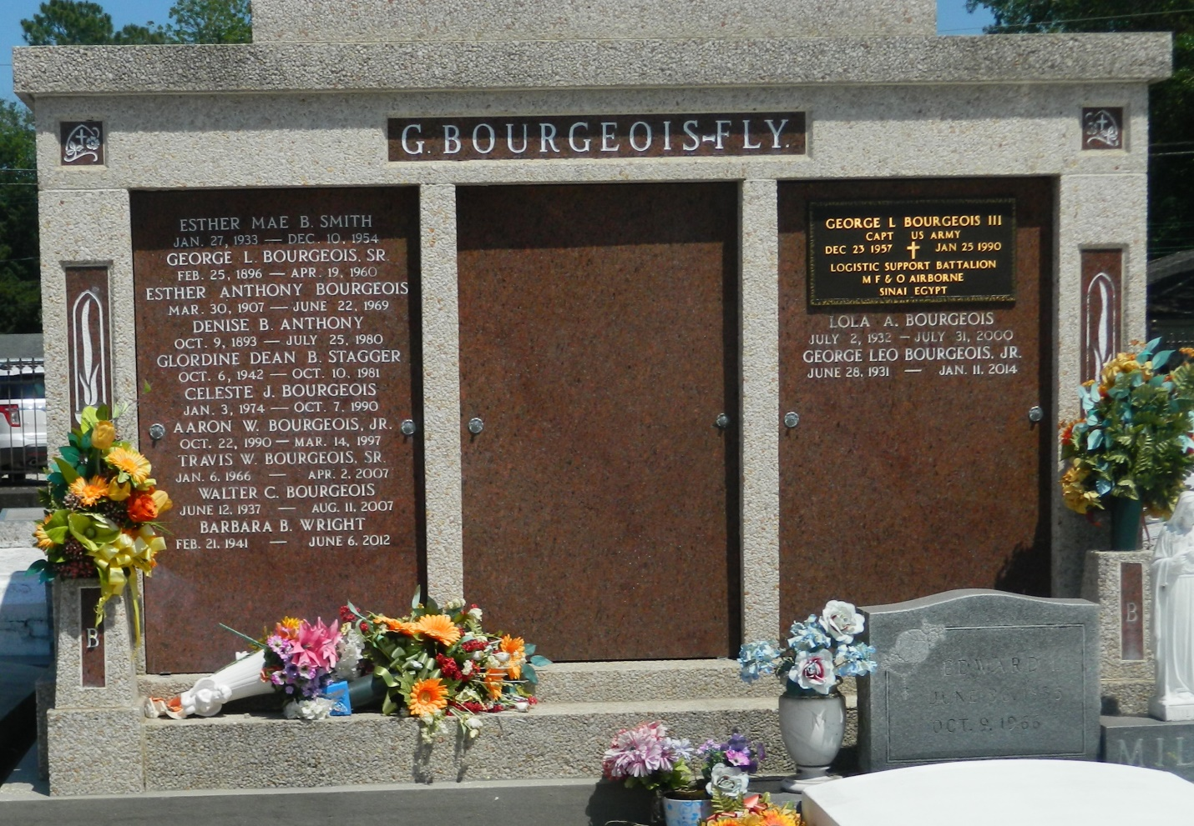

Lola Ann Bourgeois, a retired school bus driver for St. John the Baptist Parish, died July 31 from cancer at Ochsner Hospital. She was 68. Mrs. Bourgeois was a lifelong resident of LaPlace. She was a graduate of Fifth Ward High School and previously worked at Delta Match Factory. She was the past grand lady of the Knights of Peter Claver Ladies Auxiliary Court No. 73 and an honorary member of the Veterans of Foreign Wars Post No. 3337. Survivors include her husband, George Bourgeois Jr.; five sons, Eric Bourgeois of Edgard, and Clinton, Aaron, Adrian and Travis Bourgeois of LaPlace; a daughter, Patrice Austin of LaPlace; two brothers, Norman Mitchell of Long Beach, Calif., and Earl Mitchell of Baton Rouge; a sister, Annie Mae Wilson of LaPlace; 12 grandchildren; and three great-grandchildren. A Mass will be said today at 11 a.m. at Our Lady of Grace Catholic Church in Reserve. Burial will be in St. Peter's Cemetery. Robottom Mortuary is in charge of the arrangements.

Times-Picayune, The (New Orleans, LA) - Thursday, August 3, 2000

Contributed by Jane Edson