Louise (Vicknair) Bourgeois

December 21, 1869 – May 19, 1953

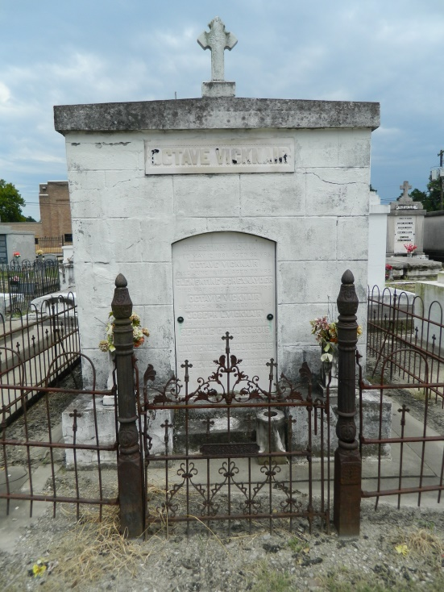 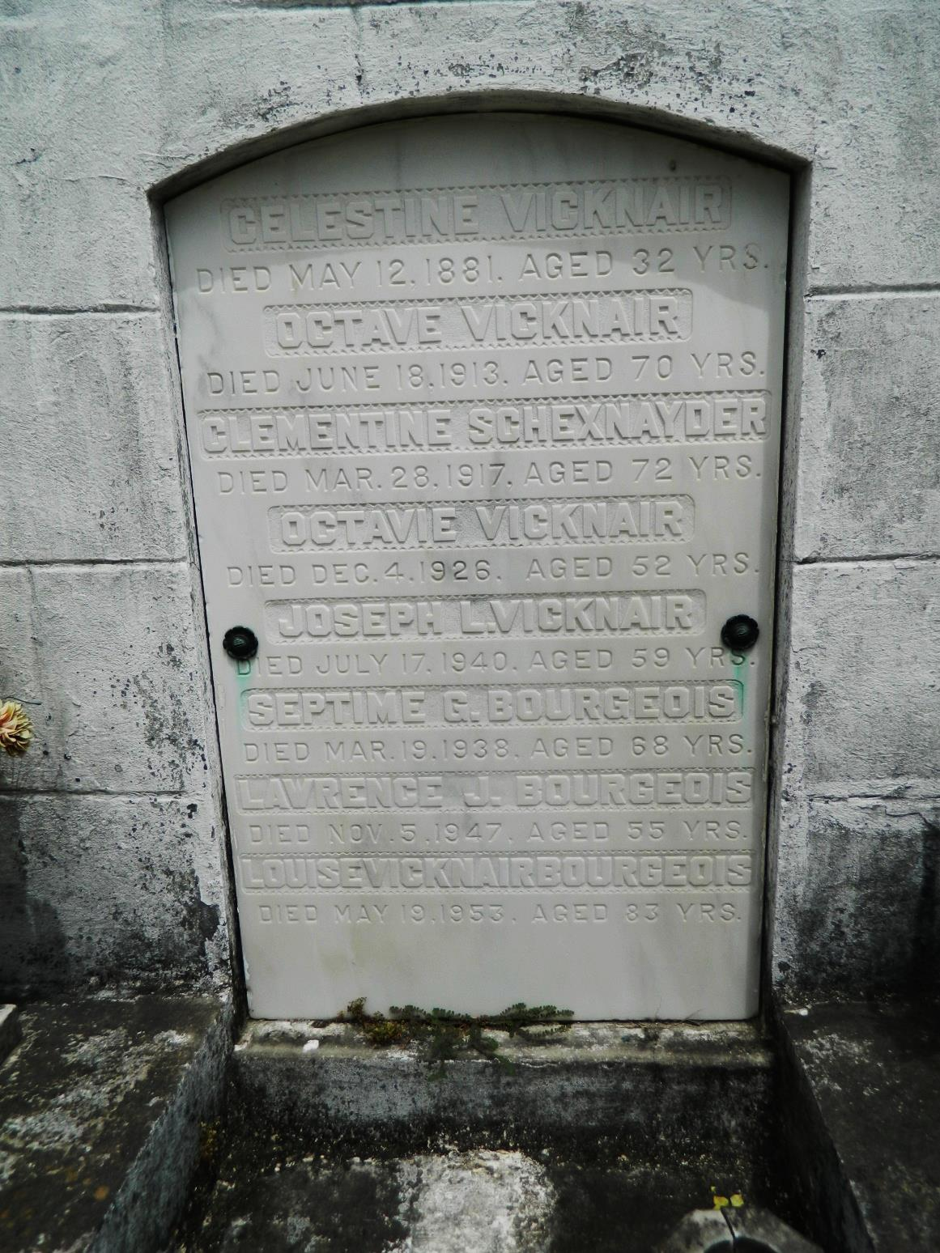

BOURGEOIS - Of 1450 North Rocheblave street, on Tuesday, May 19, 1953, at 4:05 o'clock a.m., LOUISE VICKNAIR, wife of the late Septime G Bourgeois, mother of Heloise, Gertrude, Thomas A, Octave J, Bill Bourgeois, Mrs T Ray Cary, Mrs Carl F Haase, Mrs Frances Pareti and the late Mrs Leonard Bankston and Lawrence Bourgeois, sister of Mrs J J Gebelin, also survived by 20 grandchildren and 21 great grandchildren. Relatives and friends of the family are invited to attend the funeral from the Laudumiey Funeral Home, 1225 North Rampart street near Gov Nicholls, on Wednesday, May 20, 1953, at 9 o'clock a.m., followed by mass at St Rose de Lima church. Interment in Reserve, La.

The Times-Picayune (LA), 20 May 1953, p 2

Contributed by Dwayne Montz