Marlene (Marino) Bourgeois
October 7, 1951 - April 29, 2024

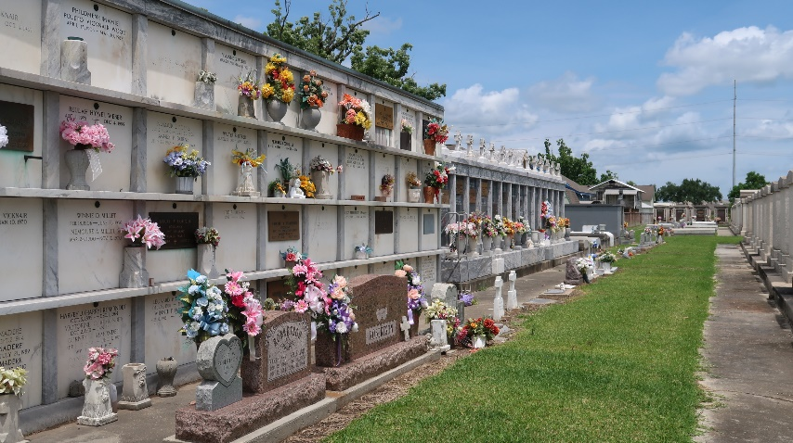

Marlene Marino Bourgeois passed away on Monday April 29, 2024 at the age of 72.
Beloved wife of Robert Bourgeois of 52 years. Loving mother of Robert Bourgeois (Kristen), Todd Bourgeois (Amanda), and Amy Boudreaux (Chase). Grandmother of Elizabeth Bourgeois, Ben Bourgeois, Emile Bourgeois, Ellie Bourgeois, Rosie Bourgeois, Emma Bourgeois, Molly Watts, Ellie Boudreaux, and Hayden Boudreaux. Daughter of the late Henry Marino and Mildred Poche Marino. Sister of Richard Marino (Linda), Charles Marino (the late Sandy), and the late Kenneth Marino (Louise). Also survived by numerous nieces, nephews, and cousins.
Relatives and friends are invited to attend the Funeral Mass at St. Joan of Arc Catholic Church, 529 W. 5th St., LaPlace on Thursday, May 2, 2024. Visitation will be held at the church from 10:00 a.m. to 12:00 p.m. followed by the Funeral Mass at 12:00 p.m. Burial immediately following the service at St. Peter Catholic Cemetery.
The family would like to thank the staff at St. Catherine Hospice and M.D. Anderson, for the excellent care they provided.
In lieu of flowers please make donations to M.D. Anderson in Marlene’s name.

Millet-Guidry Funeral Home, LaPlace, Louisiana
May 1, 2024

