Sidney S. Bourgeois

June 28, 1877 – June 7, 1957

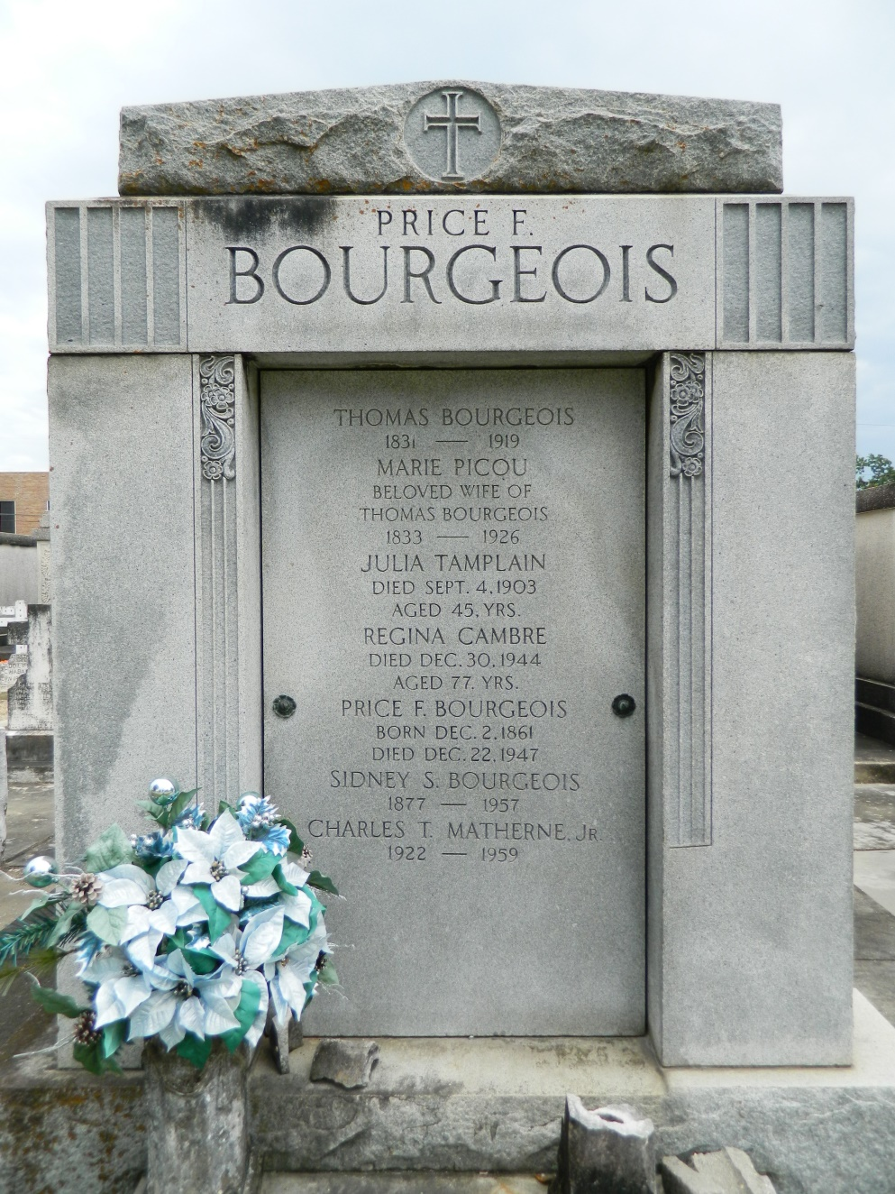

Sidney S Bourgeois died Friday, 7 Jun 1957, at 1:15 a.m. in his 80th year. He was the husband of Laure Simon and the father of Sidney S Jr and Maurice S Bourgoeis. Private services were held from P J McMahon and Sons Funeral Home, 4800 Canal Street, near cemeteries, Friday afternoon, 7 Jun 1957, followed by services at St Peter Church, Reserve, Louisiana. Interment was in St Peter Cemetery, Reserve.

The Times-Picayune (LA), 9 Jun 1957

Contributed by Dwayne Montz