Alexander J. Brady Jr.
March 8, 1937 – February 14, 2015

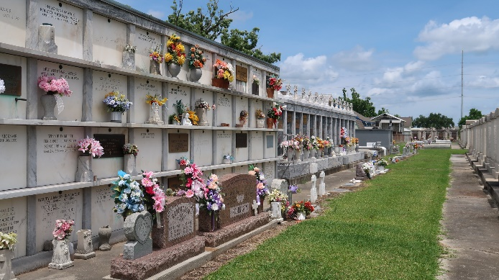

Alexander 'Al' Brady, Jr. passed away on Saturday, February 14, 2015, at the age of 77. He was a native and a lifelong resident of Reserve, LA.
Beloved husband of Mary Ann Landry Brady for 52 years. Father of Clark Brady, Kevin Brady, Beth Hitt (Eddie), Deborah LeBlanc (Chad) and Allison Duhon (Richie). Son of the late Elma Vicknair Brady and Alexander Brady, Sr. Brother of Armand Brady and Aimee B. Williams. Grandfather of Jacques Clement (Erin), Brady and Alexandra Hitt, Braxton, Colton and Dalton Duhon and Cain LeBlanc. Great-grandfather of Evie Rose Clement.
Al retired from Dupont in 1998 after 33 years of service and was a Lifetime Knights of Columbus Member.
Relatives and friends are invited to attend the Funeral Mass at St. Peter Catholic Church, 1550 Hwy. 44, Reserve, on Wednesday, February 18, 2015, at 3:00 p.m. Visitation will begin in church at 1:30 p.m. Interment in St. Peter Cemetery. In lieu of flowers, please consider a donation in his memory to St. Peter Catholic School, 188 West 7th Street, Reserve, LA 70084, or to the American Cancer Society, 2605 River Rd., New Orleans, LA 70121. Arrangements by Millet-Guidry Funeral Home.

The New Orleans Advocate (Louisiana)
Feb. 17 to Feb. 19, 2015

