Ella Ruth (Audiffred) Brady
January 7, 1925 – February 20, 1999

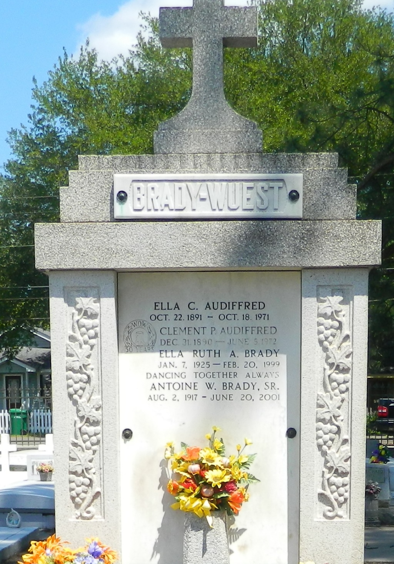

RESERVE - Ella Ruth A. Brady, 74, a native and resident of Reserve, died Feb. 20. She was the wife of Antoine W. Brady and mother of Darlin Brady-Caro and Antoine "Pop-Top" Brady Jr. She was also the sister of Myrtle Brady and Vivian Wuest. She is also survived by four grandchildren. Services were held Feb. 23 at St. Peter Catholic Church, Reserve, with interment at the church cemetery.
L'Observateur, LaPlace, Louisiana
February 24, 1999

